## BIOLOGY AND SOME MAJOR FIELDS OF SPECIALIZATION

Biology is the study of living things. It is a branch of science and like other sciences it is a way of understanding nature. Biologists deal with the living part of nature and with the non-living things which afect the living things in any way. they strive to understand, explain, integrate and describe the natural world of living things. The literal meaning of biology is the study of life.

It is very diicult to deine life. There are certain aspects of life that lie beyond the scope of the science of biology like the answers to the questions : what is the meaning of life? Why should there be life? These are the questions not usually taken up by Biologists and are left to philosophers and theologians. Biologists mainly deal with the matters relating to how life works.

Life, for biologists, is a set of characteristics that distinguish living organisms from non-living objects (including dead organisms). Living organisms are highly organized, complex entities; are composed of one or more cells; contain genetic program of their characteristics; can acquire and use energy; can carry out and control numerous chemical reactions; can grow in size; maintain a fairly constant internal environment; produce ofspring similar to themselves; respond to changes in their environment.

Any object prossessing all these characteristics simultaneously can be declared as a living thing and in an object for biological studies.

The science of biology is a very wide based study. It includes every aspect of a living thing. Therefore, volumes and volumes of information are available under this major head. It is but natural to divide the science into quite a number of branches for our convenience of comprehending and studying biology.

You are surely familiar, at this stage, with Ecology, Embryology, Physiology, Morphology (external Morphology or Anatomy), Palaeontology, Histology, Evolution, Genetics, Zoogeography etc. These are branches of biology which deal with environmental relations, development, functions, structure, form and internal gross structure, fossil, tissues, ancestral history, heredity and distribution of animals in nature, respectively. In addition to these branches there are a number of other branches of biology such as: Molecular Biology, microbiology, Marine Biology, Environmental Biology, Freshwater Biology, Parasitology, Human Biology, Social Biology, Biotechnology, etc.

**Molecular Biology**

Molecular biology is a branch of biology which deals with the structure of organisms, the cells and their organelles at molecular level.

**Environmental Biology**

Environmental Biology is the study of organisms in relation to their environment. This includes interaction between the organism and their inorganic and organic environment, especially as it relates to human activities.

**Microbiology**

This is the study of microorganisms which include Bacteria, Viruses, Protozoa and microscopic algae and fungi..

**Freshwater Biology**

This branch of biology deals with the organisms living in freshwater bodies i.e., rivers, lakes etc and physical and chemical parameters of these water bodies.

**Marine Biology**

This is the study of life in seas and oceans. This includes the study of the marine life and the physical and chemical characteristics of the sea acting as factors for marine life.

**Parasitology**

This is the branch of biology which deals with the study of parasites. The structure, mode of transmission, life histories and host - parasite relationships are studied in parasitology.

**Human Biology**

It deals with the study of man. This includes form and structure, function, histology, anatomy, morphology, evolution, genetics, cell biology and ecological studies etc. of human beings.

**Social Biology**

This is the branch of biology which deals with the study of social behaviour and communal life of human beings.

**Biotechnology**

It deals with the use of living organisms, systems or processes in manufacturing and service industries.

### LEVELS OF BIOLOGICAL ORGANIZATION

Hundreds of chemical reactions are involved in maintaining life of even the simplest organism. In view of this, it is something of surprise to ind that of the 92 naturally occurring chemical elements, only 16 are commonly used in forming the chemical compounds from which living organisms are made. These 16 elements and a few others which occur in a particular organism are called bioelements.

In the human body only six bio-elements account for 99%of the total mass.

The fact that the same 16 chemical elements occur in all organisms, and the fact that their properties difer from those in the non living world, shows that bioelements have special properties which make them particularly appropriate as basis for life.

Biological organization is not simple. It has high degree of complexity because of which the living organisms are able to carry out a number of processes (some very complicated) which distinguish them from the non living things. A living thing has built-in regulatory mechanisms which interact with the environment to sustain its structural and functional integrity.

A living thing is, therefore, composed of highly structured living substance or protoplasm. In order to understand the various phenomena of life, biologists for their convenience, study the biological organization at diferent levels starting from the very basic level of sub atomic and atomic particles to the organism itself and beyond which the study of community, population and entire world are included.

Biological organization can be divided into the following levels.

*Fig 1.2 . Levels of Organization*

#### Atomic & Subatomic Levels

All living and nonliving matter is formed of simple units called atoms and sub atomic particles such as protons, electrons & neutrons.

#### Molecular Level

In organisms elements usually do not occur in isolated forms. The atoms of diferent elements combine with each other through ionic or covalent bonding to produce compounds. This stable form is called a molecule. Hydrogen, carbon, oxygen, nitrogen, phosphorous and Ca are the most common atoms found in biological molecules. The diferent types of bonding arrangement permit biological molecules to be constructed in great variety and complexity. These may be **micromolecules** with low molecular weight like C02, H20 etc. or **macromolecules** with high molecular weights e.g. starch, proteins etc.

Biological world has two types of molecules: organic and inorganic. An organic molecule is any molecule containing both carbon and hydrogen. Inorganic molecules do not include carbon and hydrogen together in a molecule.

An organism is usually formed by enormous number of **micro** and **macro molecules** of hundreds of diferent types. Some most important and abundant organic molecules in organisms are glucose, amino acids, fatty acids, glycerol, nucleotides like ATP, ADP, AMP etc.

#### Organelles & Cell

Diferent and enormous number of micromolecules and macromolecules arrange themselves in a particular way to form cells and their organelles. In case of simple organisms like bacteria and most protists, the entire organism consists of a single cell. In most fungi, plants and animals, the organism may consist of up to trillions of cells.

Numerous sub-cellular structures like mitochondria, Golgi-complex, endoplasmic reticulum, ribosomes etc have been studied for their structure and function. It has become clear that functions of the cells are accomplished by these specialised structures comparable to the organs of the body. These structures are called **organelles**.

The arrangement of the organelles speaks of the division of labour within the cell. The prokaryotes have only a limited number and type of organelles in their cytoplasm. Eukaryotes are rich in number and kinds of membranous organelles. A cell membrane is however present in all cells whether prokoryotic or eukaryotic.

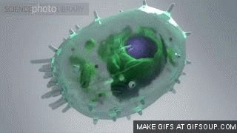

*Animation 11.9 : Cell Organelles*

*Source & Credit:*

*answer*

[*s*](http://www.answers.com/Q/What_happens_to_compounds_at_molecular_level_when_melted)

#### Tissue Level

In multicellular animals and plants, groups of similar cells are organized into loose sheets or bundles performing similar functions; these are called tissues. Each tissue has a particular function in the life of the organism e.g. muscle tissue, glandular tissue, xylem tissue, phloem tissue etc. They are specialized for contraction (movement), secretion, conducting water and for translocation of sugar, proteins etc.

#### Organ & System

Diferent tissues having related functions, assemble together in a structure to carry out its function with great eiciency. Such structures are called organs and they are specialized to perform particular functions. For example stomach which is an organ has a function of food digestion (protein part), has a secretory epithelium which secretes the gastric juice, and a muscular tissue (smooth) for contracting the walls of the stomach and mixing the food with the enzyme thoroughly and moving the food to the posterior end. The formation of organs also has a selective value because this leads to an eicient accomplishment of their functions both qualitatively and quantitatively. In animals

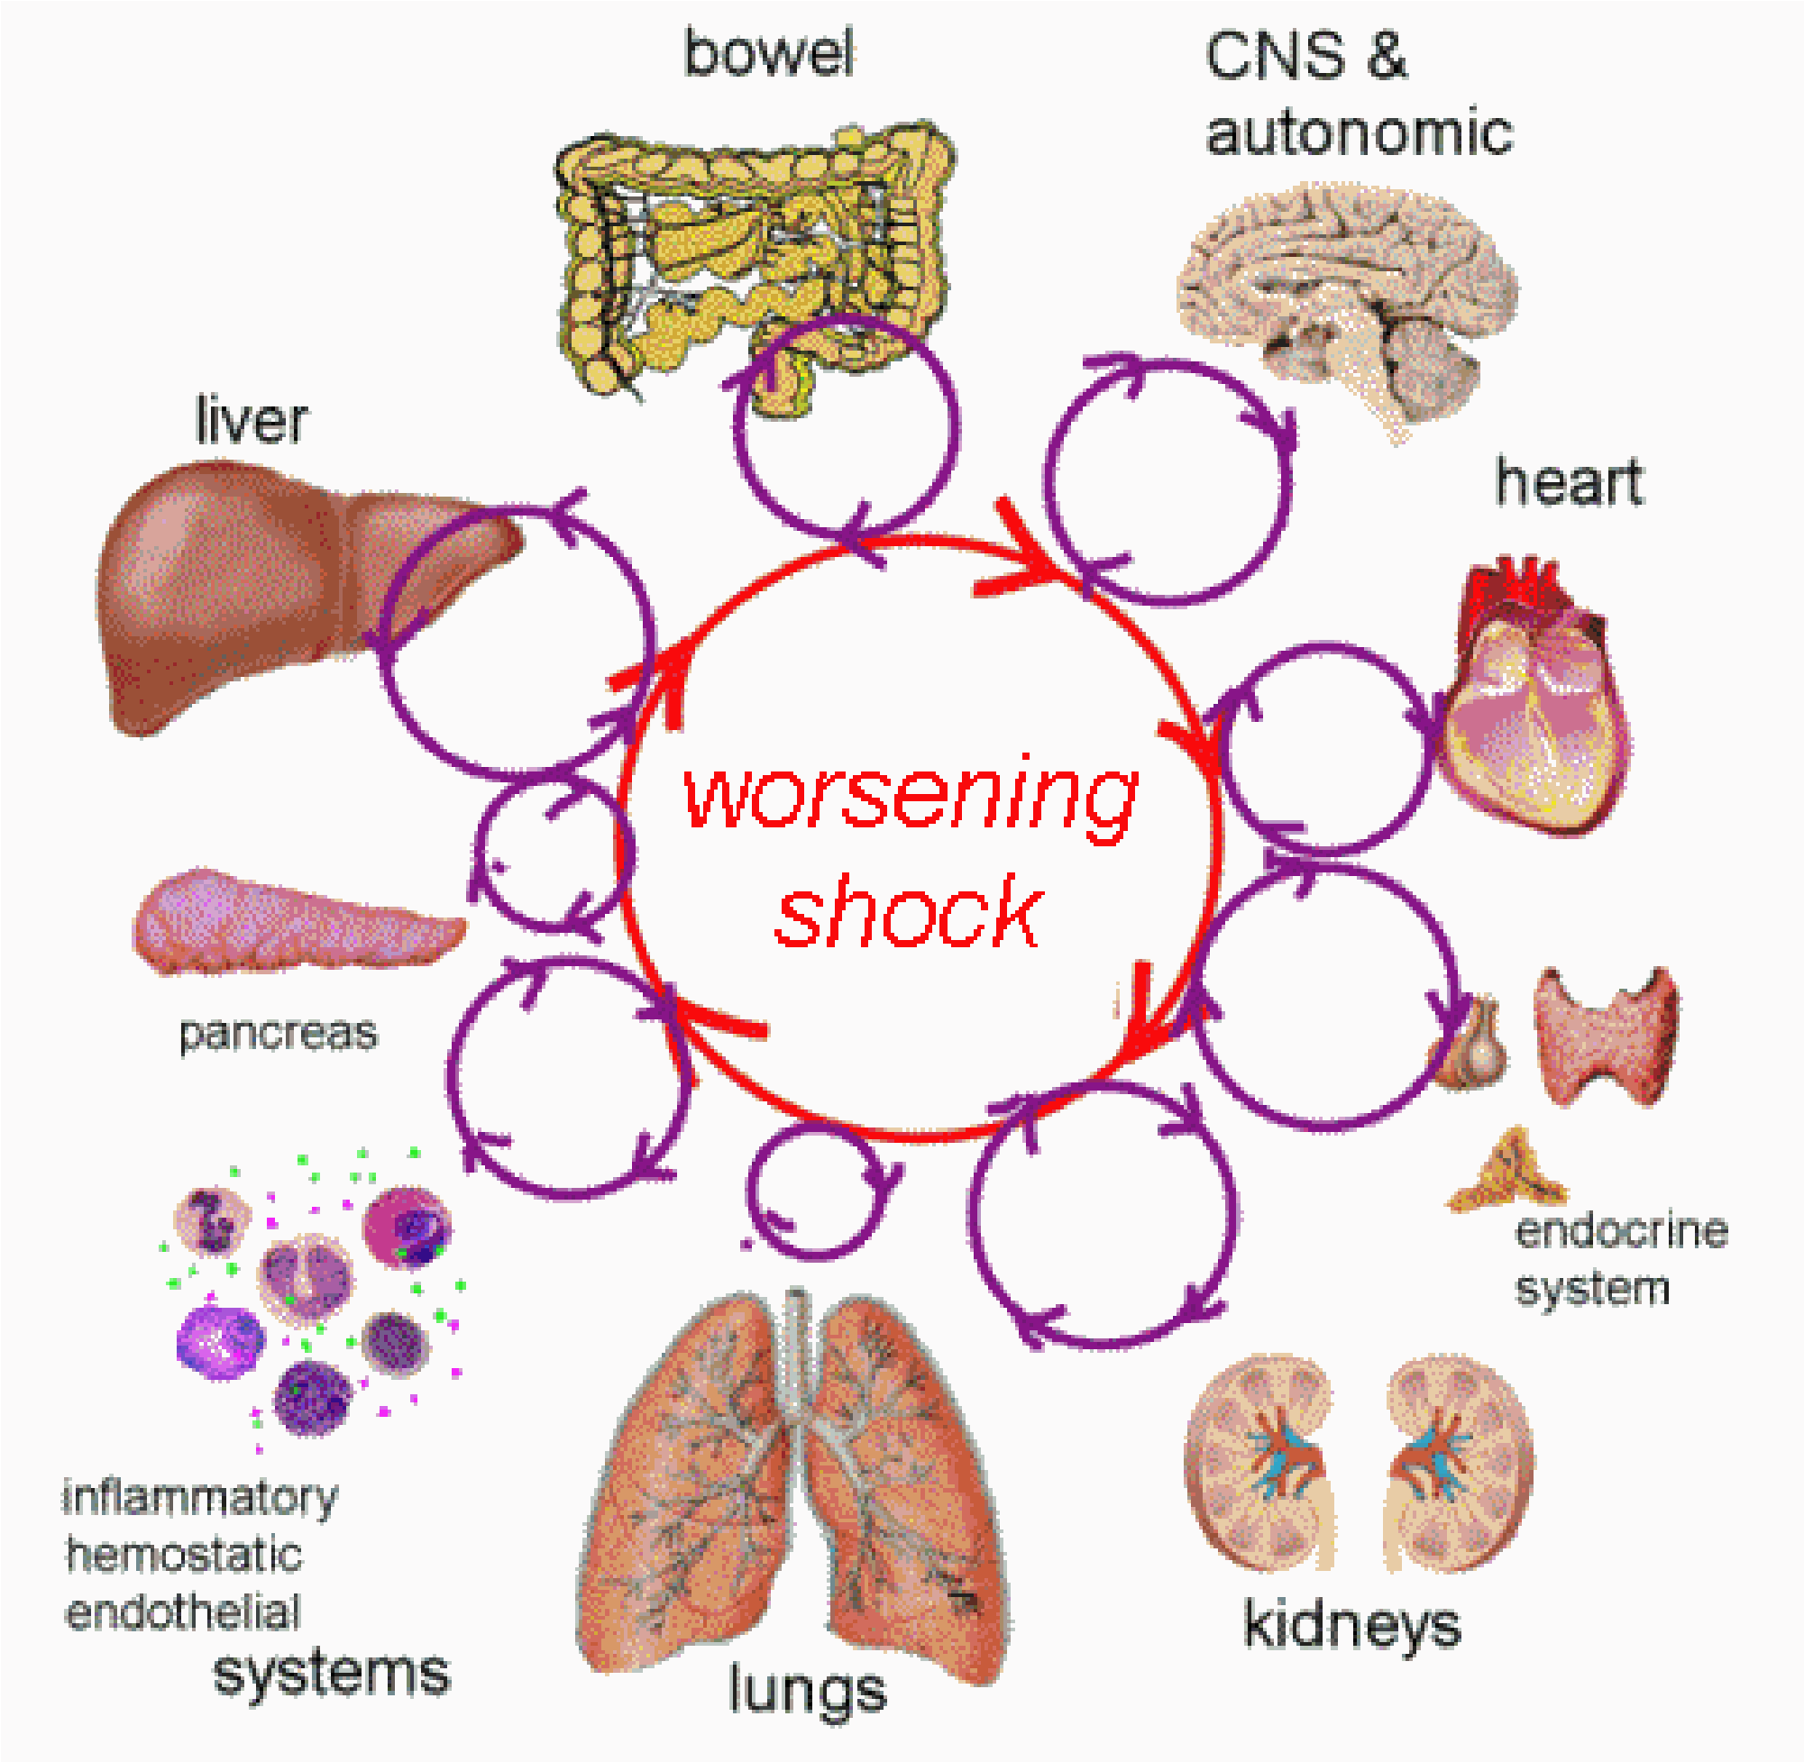

*Animation 11.10: Cell Organelles*

*Source & Credit:*

*answer*

[*s*](http://www.answers.com/Q/What_happens_to_compounds_at_molecular_level_when_melted)

organ formation is far more complex and deined. Organs are part of organ systems where total functions involved in one process or phenomenon are carried out.

The organ level of organization is much less deinite in plants than it is in animals. At the most, we might distinguish roots, stems, leaves and reproductive structures. Clear cut functions, the distinguishing features, can be assigned to each of these structures. Roots are involved in anchoring the plant, storage of food and procuring water and minerals. The shoot supports the entire plant while the leaves are primary organs for food manufacture. Flowers or other reproductive structures are involved in producing the next generation (reproduction).

The complexity of the organ systems of animals is associated with a far greater range of functions and activities than is found in plants.

#### Individual (Whole Organism)

Various organs in plants and various organ systems in animals are assembled together to form an individual - the whole organism. The whole organism has its individuality as far as its characteristics are concerned. It is diferent from other members of the same species in certain respects. The various functions, processes, activities of an organism are coordinated. In an animal all the systems work in coordination with each other. For instance if a man is engaged in continuous and hard exercise, not only his muscles are working but there is an increase in the rate of respiration and heart beat to supply the muscles with increased oxygen and food which they need for continuous exercise. In animals the coordination is achieved by means of nervous system and endocrine system, whereas in plants only long term regulation of activities is brought about by hormones.

Organism works as a whole and it interacts and responds to the environmental changes as a whole.

#### Population

A population is a group of living organisms of the same species located in the same place at the same time. Examples are the number of rats in a ield of rice, the number of students in your biology class, or human population in a city.

Population is a higher level of biological organization than organism (whole) because here a group of organisms of the same species is involved. This level of organization has its own attributes which come into being by living together of a group of organisms of the same species.

Some of these attributes are gene frequency, gene low, age distribution, population density, population pressure etc. All these are new parameters which have appeared due to population of an organism. You will study them in detail in population ecology.

#### Community

Populations of diferent species (plants and animals) living in the same habitat form a community. Communities are dynamic collections of organisms, in which one population may increase and others may decrease due to luctuation in abiotic factors. Some communities are complex and well interrelated, other communities may be simple. In a simple community any change can have drastic and long lasting efects.

The foregoing account makes it clear that an organism can be studied at diferent levels of organization. It can be studied at subatomic, atomic, molecular, macromolecular, organelle, cell, tissue, organ and organ system level. We can also look at it as an individual, as a part of population of similar individuals, as a part of a community that includes other populations and a part of community of an ecosystem which includes abiotic factors as well as living organisms, Fig. 1.2.

The organisms, interaction can take many shapes. It may be predation, parasitism, commensalism, mutualism and competition.

#### Living World in Space

Living world of today is enormous in size. It has been reproducing and evolving since the time of its origin on this planet. Today almost all parts of the world abounds in living organisms. The distribution of organisms in space can be studied through biomes.

A **biome** is a large regional community primarily determined by climate. It has been found that the major type of plant determines the other kind of plants and animals. These biomes have, therefore, been named after the type of major plants or major feature of the ecosystem. The major biomes of the world you will study in the chapter of ecology.

## LIVING WORLD IN TIME

Since the time of origin of life on this planet, various organisms were evolved and dominated this planet during various periods of geological time chart. This has been found by the evidence obtained from the discovery and study of fossils which allows biologists to place organisms in a time sequence. As geological time passes and new layers of sediments are laid down, the older organisms should be in deeper layer, provided the sequence of the layers has not been disturbed.

In addition it is possible to date/age rocks by comparing the amounts of certain radioactive isotopes they contain. The older sediment layers have less of these speciic radioactive isotopes than the younger layers. A comparison of the layers gives an indication of the relative age of the fossils found in the rocks. Therefore, the fossils found in the same layer must have been alive during the same geological period.

You can have an idea about the temporal distribution of various forms of life both plants and animals in the various geological periods ( ig.1.3).

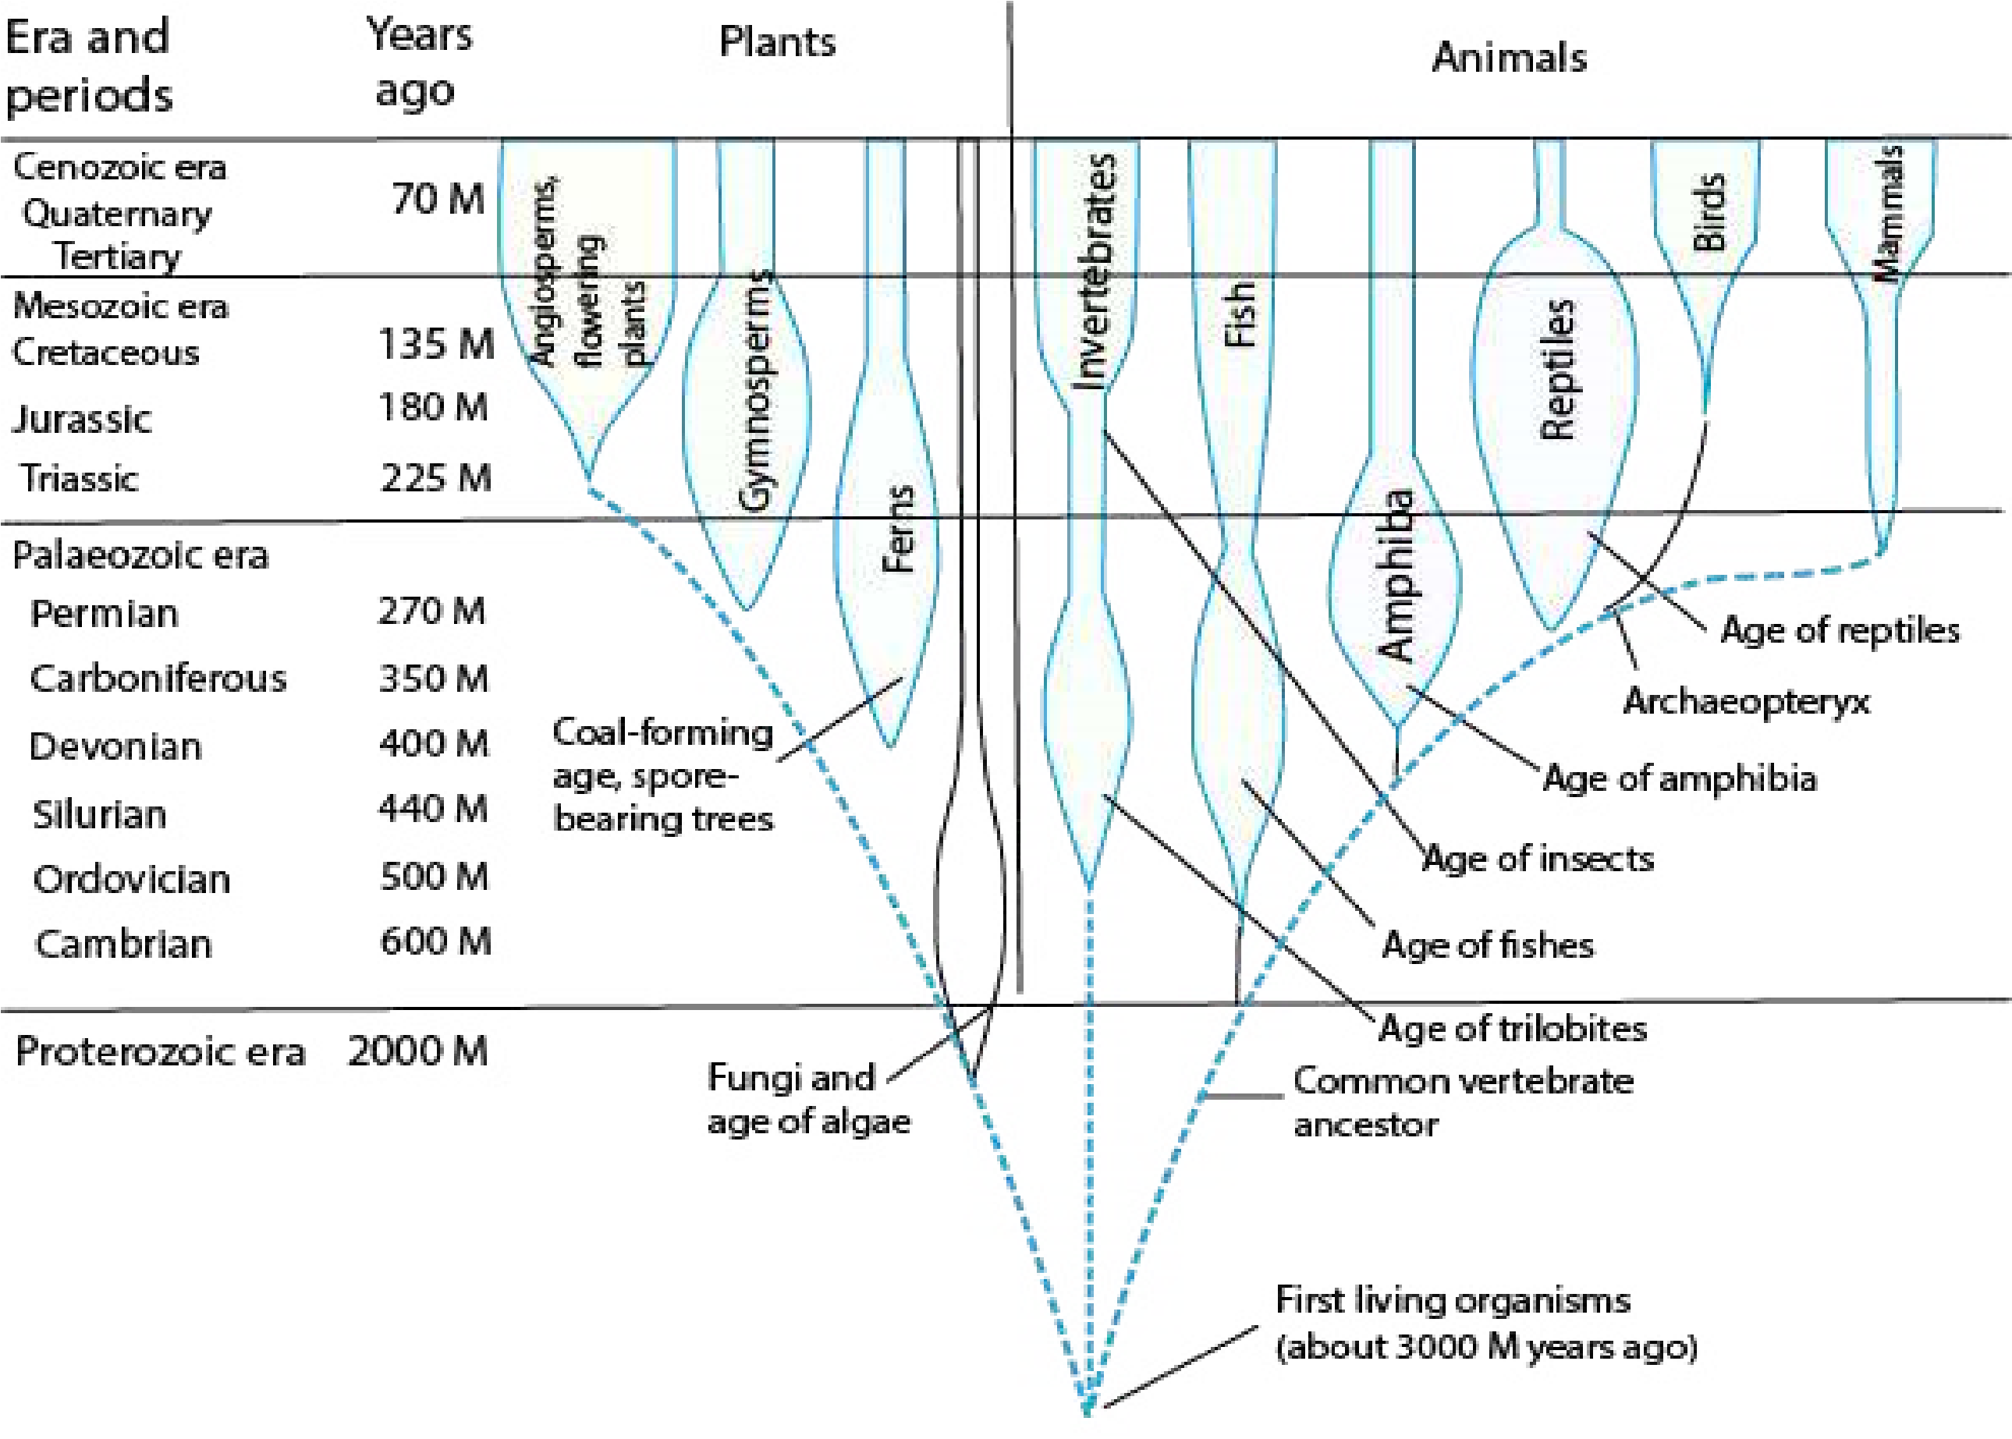

*Fig 1.3. Fossil record of plants and animals shown in a geological time chart*

### Phyletic Lineage

When we look at the biodiversity (the number and variety of species in a place), we ind that there are nearly 2,500,000 species of organisms, currently known to science. More than half of these are insects (53.1%) and another 17.6 % are vascular plants. Animals other than insects are 19.9 % (species) and 9.4 % are fungi, algae, protozoa, and various prokaryotes.

This list is far from being complete. Various careful estimates put the total number of species between 5 and 30 millions. Out of these only 2.5 million species have been identiied so far.

The life today has come into existence through Phyletic lineages or evolving populations of the organisms living in the remote past. Evolutionary change often produces new species and then increases biodiversity. A phyletic lineage is an unbroken series of species arranged in ancestor to descendant sequence with each later species having evolved from one that immediately proceded it. If we had a complete record of the history of life on this planet, every lineage would extend back in time to the common origin of all early life. We lack that record because many soft bodied organisms of the past had not left their preserved record as fossils.

### Biological Method

Science is a systematized knowledge. Like other sciences, biological sciences also have a set methodology. It is based on experimental inquiry. It always begins with chance observation. Observations are made with ive senses viz, vision, hearing, smell, taste and touch, depending upon their functional ability. Observations can both be qualitative and quantitative. Quantitative observations have accuracy over qualitative as in the former variables are measurable and are recorded in terms of numbers. An observer organizes observations into data form and gives a statement as per experience and background knowledge of the event. This statement is the **hypothesis,** which is tentative explanation of observations.

At this stage you should look at the ways of devising hypothesis. There are two ways of formulating hypothesis. A hypothesis can be the result of deductive reasoning or it can be the consequence of inductive reasoning.

**Deductive reasoning** moves from the general to the speciic. It involves drawing speciic conclusion from some general principle/assumptions. Deductive logic of “if ....... then” is frequently used to frame testable hypothesis. For example, if we accept that all birds have wings (premise #1), and that sparrows are birds (premise # 2), then we conclude that sparrows have wings. If all green plants require sunlight for photosynthesis, then any green plant when placed in dark would not synthesize glucose, the end product of photosynthesis. The other way of reasoning used in the formulation of hypothesis is **inductive reasoning** which is reasoning from the speciic to the general. It begins with speciic observations, and leads to the formation of general principle. For instance, if we know that sparrows have wings and are birds, and we know that eagle, parrot, hawk, crow are birds, then we induce (draw conclusion) that all birds have wings. The science also, therefore, uses inductive methods to generalize from speciic events.

In fact sometimes scientists also use other ways to form a hypothesis, which may include (1) intuition or imagination (2) esthetic preference (3) religious or philosophical ideas (4) comparison and analogy with other processes (5) discovery of one thing while looking for some other thing. These ways can also sometimes form basis for scientiic hypothesis. Hypotheses as you already know, are subjected to rigorous testing.

Repeated exposure of a hypothesis to possible falsiication increases scientist’s conidence in the hypothesis when it is not falsiied. Any hypothesis that is tested again and again without ever being falsiied is considered well supported and is generally accepted. This may be used as the basis for formulating further hypothesis. So there is soon a series of hypotheses supported by the results of many tests which is then called a theory. A good theory is predictive and has explanatory power. One of the most important features of a good theory is that it may suggest new and diferent hypotheses. A theory of this kind is called productive.

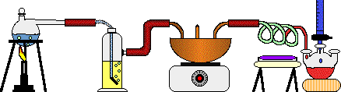

*Animation 11.11 : Biological Method*

*Source & Credit:*

*wikispac*

[*e*](https://www.wikispaces.com/)

However even in the case of productive theory the testing goes on. In fact many scientists take it as a challenge and exert even greater eforts to disprove the theory. If a theory survives this skeptical approach and continues to be supported by experimental evidence, it becomes a scientiic law. A **scientiic law** is a uniform or constant fact of nature, it is virtually an irrefutable theory. Biology is short in laws because of elusive nature of life.

Examples of biological laws are Hardy-Weinberg law and Mendel’s laws of inheritance. You will learn about them in later chapters. You can see that laws are even more general than theories and aford answers to even more complex questions, therefore there are relatively a few laws in biology.

### BIOLOGY AND THE SERVICE OF MANKIND

The science of biology has been helping mankind in many ways in increasing food production; in combating diseases and in protecting and conserving environment. Biological advances in the ield of food and health have resulted in high standard of living.

Plant production has been tremendously increased by improving existing varieties and developing new high-yield and disease - resistant varieties of plants and animals used as food.

Plant and animal breeders have developed, through selective breeding, using the principles of genetics, new better varieties of wheat, rice, corn, chicken, cow and sheep. Poultry breeders have developed broilers for getting quick and cheap white meat. Genes for disease resistance and other desirable characters are introduced into plant, using the techniques of **genetic engineering**. Such **transgenic plants** (plants having foreign DNA incorporated into their cells) can be propagated by **cloning** (production of genetically identical copies of organisms/cells by asexual reproduction) using special techniques such as **tissue culture techniques** etc. Plant pathogenic fungi and insect pests of crops which weaken the plants and reduce the yield had traditionally been controlled by using chemical fungicides and insecticides (pesticides). Use of these chemicals poses toxicity problems for human beings as well as environmental pollution. Moreover, there are chances of insects becoming resistant to the efect of these chemicals. **Biological control** (control by some living organisms) eliminates all such hazards. In biological control, pests are destroyed by using some living organisms that compete with or even eat them up. An aphid that attacks walnut tree is being controlled biologically by a wasp that parasitizes this aphid.

Even some bacteria are being used as bio-pesticides. Efective control of a particular disastrous disease, or all the common diseases of a plant can be achieved by using all relevant, appropriate methods of disease control. Such an approach of disease control is called “**integrated disease management**”.

Soil is a complex medium. It is almost impossible to conduct experiments on nutrient requirements of plants by growing them in soil. **Hydroponic culture technique** is used to test whether a certain nutrient is essential for plant or not. In this technique the plants are grown in aerated water to which nutrient mineral salts have been added. Hydroponic farming, however, is yet not feasible. Astronauts may use it for growing vegetables.

Diferent techniques of food preservation have been developed for protecting food from spoilage and for its use and transport over long distance without damaging its quality. One of these is **pasteurization,** developed by Louis Pasteur. It is being widely used for preservation of milk and milk products.

#### Disease Control

There has been fantastic progress in the area of health and disease control. Three pronged actions are usually taken against various diseases.

1. Preventive measures
2. Vaccination/Immunization
3. Drug treatment/Gene therapy

#### Preventive measures

The advances in biological sciences have provided us information about the causative agents of the diseases and their mode of transmission. For instance the AIDS (Acquired Immune Deiciency Syndrome) is caused by HIV (human immuno deiciency virus) and it spreads through free sexual contact, through blood transfusion, by using contaminated syringes or surgical instruments etc. Therefore, doctors advise us to take precautions on these fronts so that we do not contract the disease, which is at present incurable. Similarly hepatitis is caused by H.virus which is spread through blood transfusion by using contaminated syringes and surgical instruments etc. In this case also doctors advise us to be careful and avoid the point of contact.

#### Vaccination / Immunization

Many diseases such as polio, whooping cough, measles, mumps etc can easily be controlled by vaccination or “shots”.

Edward Jenner irst developed the technique of vaccination in 1796, cowpox pus is known as vacca (from latin vacca=cow). From this word evolved the present term vaccination and vaccine. You will learn more about vaccination in chapter 6.

Since then, inoculation or vaccination is carried out to make the people immune from viral or bacterial epidemics or, for some diseases the individuals are vaccinated in their early life to make them immune to those diseases.

It is claimed that small pox has been totally eliminated from the world by using this method. Scientists are making continuous eforts to develop vaccine against other diseases. Even vaccine against AIDS is being administered in humans on experimental basis.

#### Drug treatment / Gene therapy

If a person becomes sick with disease, he is subjected to the action of **antibiotics** which can kill bacteria. The antibiotics are, however, useful in bacterial disease and that only when bacteria have not developed resistance to antibiotics. In cancer, **radiotherapy** and **chemotherapy** are also used. In radiotherapy, the cancerous part is exposed to short wave radiations from the radioactive material repeatedly at regular intervals. In Pakistan there are several centres which are carrying out radiotherapy to control cancer. Chemotherapy consists of administrating certain anticancer chemicals to the patients at regular intervals. These chemicals may kill both cancerous and normal cells.

Recently a new technique has been developed to repair defective genes. This consists of isolating the normal gene and inserting it into the host through bone marrow cells. This is called **gene therapy.**

Combating disease utilizing all methods as and when required and ensuring a participation of community in this programme is known as **integrated disease management**. This requires awareness of the community about the severity of the problem, its causes and its remedies. This is a very efective programme for elimination and control of dangerous diseases from the human society.

Besides its contribution to food production and health of man, biology has discovered a number of means and developed technologies for the welfare of mankind as for example cloning, protection and conservation of environment etc.

**Cloning**: Cloning is a technology for achieving **eugenic aims**. A **clone** is deined as a cell or individual and all its asexually produced ofspring. All members of a clone are genetically identical except when a mutation occurs.

Generally no normal animal reproduces naturally by cloning. Several insects and many plants do, in some circumstances whereas few do so regularly.

In 1997 scientists in Scotland succeeded in cloning a sheep. Other mammalian species (mice and cows) have since been cloned. In this procedure the nucleus from a fertilized egg is removed and a nucleus from a cell of a fully developed individual is inserted in its place. The altered zygote is then implanted in a suitable womb where it completes its development. The new individual formed in this way is a genetically identical clone of the individual whose nucleus was used. Thus cloning could make multiple copies of a desired genotype.

Another type of cloning is the division of a single egg or early embryo into one or more separate embryos. This is the same process that normally creates identical twins. Ofspring from this type of cloning are genetically identical but carry chromosomes from each of the two parents. This type of cloning has already been used to produce genetically identical cattle and other farm animals.

Man is likely to adopt cloning techniques for commercial production of valuable animals of known pedigree such as horses etc.

At some places scientists are making attempts to clone human embryo which they believe can serve as transplant donor. There is a lot of controversy on this issue as to whether human cloning should be attempted or not.

### PROTECTION AND CONSERVATION OF ENVIRONMENT

Industrialization has helped mankind to raise the standard of living. It has at the same time destroyed our environment. Tons of industrial waste, and eluents in solid, liquid or gas form are being injected into the environment by the industries. These eluents frequently contain sizeable amount of certain very toxic even carcinogenic materials. Heavy metals like lead from automobiles, chromium from tanneries, are playing havoc to human health. Environmental pollution has reached alarming level in some countries.

This problem, therefore, needs to be addressed or else it would soon be out of control in which case the biocomponents of the world ecosystem would sufer irreparable loss and this environment would no longer support life on this planet.

Biology has helped mankind in attracting attention to this problem and the biologists are striving to ind the solution to set this environment right wherever it has deteriorated: Biologists have already asked for the treatment of industrial eluents to be made obligatory. Several ways of bioremediation (removal or degradation of environmental pollutants or toxic materials by living organisms) are also under investigation. For example algae have been found to reduce pollution of heavy metals by bioabsorption.

Biologists are also working out the list of **endangered species** of plants and animals which if not protected would soon be extinct. They have, therefore, stressed the needs for their protection.

The environmental pollution is a national problem in Pakistan. Our rivers, canals are highly polluted with the mixing of city sewage and industrial wastes. The life in fresh water of Pakistan is towards decline. Fish populations have been most adversely afected. We need to take protective measures as early as possible. In cities, particularly the exhaust from automobiles is enormously adding lead into the atmosphere. There is then a need for lead free petrol to reduce the pollution.



*Animation 11.12 : Protection and Conservatin of Environment*

*Source & Credit:*

*epd.ntp*

[*c*](http://www.epd.ntpc.gov.tw/en/waste-management-and-planning-en/content/199.html)

#### Exercise

**Q.1. Fill in the blanks**

1. ____________________ is the study of organisms in relation to their environment.
2. The study of organisms living in fresh water bodies like rivers, lakes etc is called ________________________.
3. ______________ is the branch of biology which deals with the study of social behaviour and communal life of human beings.
4. In the ________________ body only six bio-elements accounts for 99% of the total mass.
5. All living things and nonliving things are formed of simple units called _____________________.
6. Various organs in plants and various organ systems in animals are assembled together to form an ________________________.
7. A __________________ is a group of organisms of the same species located in the same place at the same time.
8. A __________________ is based upon observations.
9. A hypothesis is a result of deductive reasoning or it can be the consequence of _____________ reasoning.

**Q.2. Write whether the statement is ‘true’ or ‘false’ and write the correct statement if it is false.**

1. Penicillin was discovered by Edward Jenner from a fungus Penicillium.
2. Many diseases such as polio, whooping cough, measles, mumps etc can be controlled by antibiotics.
3. Exposure to the small pox virus allows the body to develop immunity against cowpox virus.
4. AIDS is caused by HIV and it spreads through sexual contacts, blood transfusion, by contaminated syringe or surgical instruments. **Q.4. Short questions.**
5. What do you mean by hypothesis?
6. How does law difer from theory?
7. What is deductive reasoning ?(iv) Deine vaccination.

(v) Write a short note on cloning.

**Q.5. Extensive question.**

1. Deine the following branches of biology:

Molecular Biology, Microbiology, Marine Biology, Biotechnology

1. Discuss briely phyletic lineage in biological organization.
2. Write notes on the following:

(a) Living world in space and time (b) Population (c) Community

1. Explain the biological method for solving a biological problem. How do deductive and inductive reasoning play an important role in it?
2. What is the role of the study of Biology in the welfareof mankind?

CHAPTER

# 2 Biological Molecules

*Animation 2.1 : Molecular Biology*

[*Source & Credit: g*](http://anatomyeshs.wikispaces.com/Ch.16+Respiratory+System)[*odandscience*](http://www.godandscience.org/evolution/all_about_dna.html)

## INTRODUCTION TO BIOCHEMISTRY

Biochemistry is a branch of Biology, which deals with the study of chemical components and the chemical processes in living organisms. A basic knowledge of Biochemistry is essential for understanding anatomy and physiology, because all of the structures of an organism have biochemical organization. For example, photosynthesis, respiration, digestion, muscle contraction can all be described in biochemical terms.

All living things are made of certain chemical compounds, which are generally classiied as organic and inorganic. Most important organic compounds in living organisms are carbohydrates, proteins, lipids and nucleic acids. Among inorganic substances are water, carbon dioxide, acids, bases, and salts.

Typically an animal and a bacterial cell consists of chemicals as shown in the following table.

**Table 2.1 Chemical composition of a Bacterial and a Mammalian cell.**

|  |  |  |
| --- | --- | --- |
| **Chemical components** | **% total cell weight**  **Bacterial cell Mammalian cell** | |
| 1 Water | 70 | 17 |
| 2 Proteins | 15 | 18 |
| 3 Carbohydrates | 3 | 4 |
| 4 Lipids | 2 | 3 |
| 5 DNA | 1 | 0.25 |
| 6 RNA | 6 | 1.1 |
| 7 Other organic molecules (Enzymes, hormones, metabolites) | 2 | 2 |
| 8 Inorganic ions  (Na+, K+, Ca++, Mg++  Cl-, SO -- etc) | 1 1 | |

4

The survival of an organism depends upon its ability to take some chemicals from its environment and use them to make chemicals of its living matter. For this reason, cells of every organism are constantly taking in new substances and changing them chemically in various ways i.e. building new cellular materials and obtaining energy for their needs. Life of an organism depends upon the ceaseless chemical activities in its cells. This chemical activity is maintained with a high degree of organization. All the chemical reactions taking place within a cell are collectively called metabolism. Metabolic processes are characterized as anabolism and catabolism. Those reactions in which simpler substances are combined to form complex substances are called anabolic reactions. Anabolic reactions need energy. Energy is released by the break down of complex molecules into simpler ones, such reactions are called catabolic reactions. Anabolic and catabolic reactions go hand in hand in the living cells. Complex molecules are broken down and the resulting smaller molecules are reused to form new complex molecules. Interconversions of carbohydrates, proteins, and lipids that occur continuously in living cells are examples of co-ordinated catabolic and anabolic activities.

*Animation 2.2: Introduction to BioChemistry*

*Source and Credit:*

*wikido*

[*c*](http://www.wikidoc.org/index.php/Biochemistry)

## IMPORTANCE OF CARBON

Carbon is the basic element of organic compounds.

Due to its unique properties, carbon occupies the Covalent bonds result when two or more central position in the skeleton of life. atoms complete their electron shells by sharing electrons. When an electron pair

Carbon is tetravalent. It can react with many other is shared between two atoms, a single known elements forming covalent bonds. covalent bond results. An example is the bond between two hydrogen atoms to form

When a carbon atom combines with four a hydrogen molecule. Covalent bond stores atoms or radicals, the four bonds are arranged large amount of energy.

symmetrically in a tetrahedron, and result to give a stable coniguration. The stability associated with the tetravalency of carbon atoms makes it a favourable element for the synthesis of complicated cellular structures. Carbon atoms can also combine mutually forming stable, branched or unbranched chains or rings. This ability of carbon is responsible for the vast variety of organic compounds. C - C bonds form a skeleton of organic molecules as shown in Fig. 2.1

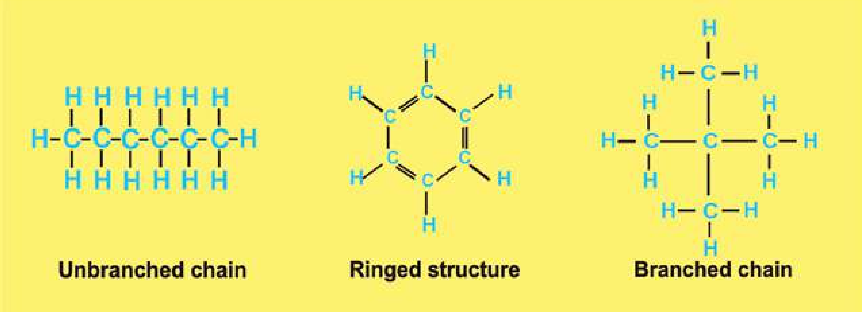

*Fig. 2.1. : Unbranched and branched chains, and ring structure form and by C-C bonds.*

Carbon combines commonly with H, O, N, P and S. Combinations with these and other elements contribute to the large variety of organic compounds. Carbon and hydrogen bond (C-H bond) is the potential source of chemical energy for cellular activities. Carbon-oxygen association in glycosidic linkages provides stability to the complex carbohydrate molecules. Carbon combines with nitrogen in amino acid linkages to form peptide bonds and forms proteins which are very important due to their diversity in structure and functions.

Large organic molecules (macromolecules) such as cellulose, fats, proteins, etc. are generally insoluble in water, hence they form structures of cells. They also serve as storage for smaller molecules like glucose, which in turn are responsible for providing energy to the body.

Small molecules, such as glucose, amino acids, fatty acids etc. serve either as a source of energy, or as subunits to build macromolecules. Some small molecules are so unstable that they are immediately broken down to release energy e.g. ATP. Such substances serve as immediate source of energy for cellular metabolism.

*Animation 2.3: Carbon*

*Source and Credit: Rebloggy*

## IMPORTANCE OF WATER

Water is the medium of life. It is the most abundant compound in all organisms. It varies from 65 to 89 percent in diferent organisms. Human tissues contain about 20 per cent water in bone cells and 85 percent in brain cells. Almost all reactions of a cell occur in the presence of water. It also takes part in many biochemical reactions such as hydrolysis of macromolecules. It is also used as a raw material in photosynthesis.

### Solvent properties

Due to its polarity, water is an excellent solvent for polar substances. Ionic substances when dissolved in water, dissociate into positive and negative ions. Non-ionic substances having charged groups in their molecules are dispersed in water. When in solution, ions and molecules move randomly and are in a more favourable state to react with other molecules and ions. It is because of this property of water that almost all reactions in cells occur in aqueous media. In cells all chemical reactions are catalyzed by enzymes which work in aqueous environment. Nonpolar organic molecules, such as fats, are insoluble in water and help to maintain membranes which make compartments in the cell.

### Heat capacity

Water has great ability of absorbing heat with minimum of change in its own temperature. The speciic heat capacity of water - the number of calories required to raise the temperature of 1g of water from 15 to 16°C is 1.0. This is because much of the energy is used to break hydrogen bonds. Water thus works as temperature stabilizer for organisms in the environment and hence protects living material against sudden thermal changes.

*Animation 2.4: Heat Capacity*

*Source and Credit:* [*dynamicscience*](http://www.dynamicscience.com.au/tester/solutions1/chemistry/heatcpcty.htm)

### Heat of vaporization

Water absorbs much heat as it changes from liquid to gas. Heat of vaporization is expressed as calories absorbed per gram vaporized. The speciic heat of vaporization of water is 574 Kcal/kg, which plays an important role in the regulation of heat produced by oxidation. It also provides cooling efect to plants when water is transpired, or to animals when water is perspired. Evaporation of only two ml out of one liter of water, lowers the temperature of the remaining 998 ml by 1°C.

### Ionization of water

The water molecules ionize to form H+ and OH- ions:

H20 m H+ + OH-

This reaction is reversible but an equilibrium is maintained. At 25°C the concentration of each of H+ and OH- ions in pure water is about 10-7 mole/litre. The H+ and OH- ions afect, and take part in many of the reactions that occur in cells.

### Protection

Water is efective lubricant that provides protection against damage resulting from friction. For example, tears protect the surface of eye from the rubbing of eyelids, water also forms a luid cushion around organs that helps to protect them from trauma.

### CARBOHYDRATES

Carbohydrates occur abundantly in living organisms. They are found in all organisms and in almost all parts of the cell. Cellulose of wood, cotton and paper, starches present in cereals, root tubers, cane sugar and milk sugar are all examples of carbohydrates. Carbohydrates play both structural and functional roles. Simple carbohydrates are the main source of energy in cells. Some carbohydrates are the main constituents of cell walls in plants and micro-organisms.

The word carbohydrate literally means hydrated carbons. They are composed of carbon, hydrogen and oxygen and the ratio of hydrogen and oxygen is the same as in water. Their general formula is Cx (H20 )y where(x) is the whole number from three to many thousands whereas y may be the same or diferent whole number. Chemically, carbohydrates are deined as polyhydroxy aldehydes or kentones, or complex substances which on hydrolysis yield polyhydroxy aldehyde or ketone subunits. (Hydrolysis involves the break down of large molecules into smaller ones utilizing water molecules).

The sources of carbohydrates are green plants. These are the primary products of photosynthesis. Other compounds of plants are produced from carbohydrates by various chemical changes.

Carbohydrates in cell combine with proteins and lipids and the resultant compounds are called glycoproteins and glycolipids, respectively. Glycoproteins and glycolipids have structural role in the extracellular matrix of animals and bacterial cell wall. Both these conjugated molecules are components of biological membranes.

#### Classiication of Carbohydrates

Carbohydrates are also called ‘saccharides’ (derived from Greek word ‘sakcharon’ meaning sugar) and are classiied into three groups: (i) Monosaccharides (ii) Oligosaccharides, and (iii) Polysaccharides.

**Monosaccharides:** These are simple sugars. They are sweet in taste, are easily soluble in water, and cannot be hydrolysed into simpler sugars. Chemically they are either polyhydroxy aldehydes or ketones. All carbon atoms in a monosaccharide except one, have a hydroxyl group. The remaining carbon atom is either a part of an aldehyde group or a keto group. The sugar with aldehyde group is called aldo-sugar; and with the keto group as keto-sugar. These are indicated in the case of two trioses sketched below (Fig. 2.2).

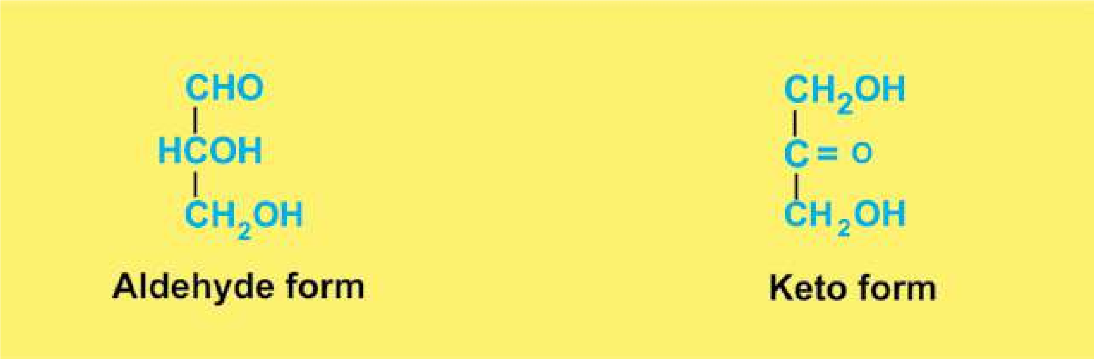

*Fig. 2.2: Structure of glyceraldehyde, a 3C Sugar (C3H6O3). The aldehyde form is glyceraldehyde, whereas ketonic form is dihydroxyacetone.*

In nature monosaccharides with 3 to 7 carbon atoms are found. They are called trioses (3C), tetroses (4C), pentoses (5C), hexoses (6C), and heptoses (7C). They have general formula (CH2O)n. where n is the whole number from three to seven thousands.

Two trioses mentioned above are, intermediates in respiration and photosynthesis. Tetroses are rare in nature and occur in some bacteria. Pentoses and hexoses are most common. From the biological point of view the most important hexose is glucose. It is an aldose sugar. Structure of ribose and glucose is given below (Fig. 2.3).

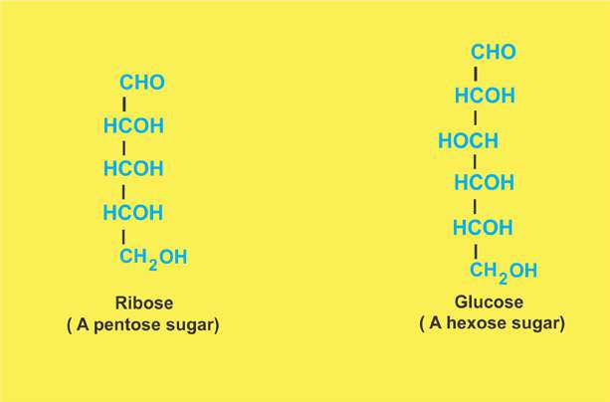

*Fig. 2.3 Structure of Ribose and Glucose.*

Most of the monosaccharides form a ring structure when in solution. For example ribose will form a ive cornered ring known as ribofuranose, whereas glucose will form six cornered ring known as glucopyranose ( Fig. 2.4).

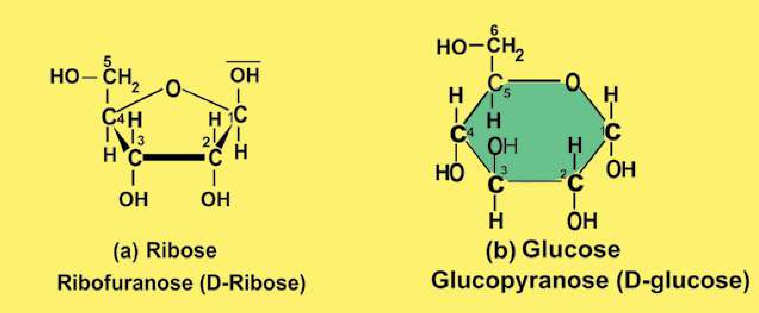

*Fig. 2.4 Ribose and glucose form ring shaped structures.*

In free state, glucose is present in all fruits, being abundant in grapes, igs, and dates. Our blood normally contains 0.08% glucose. In combined form, it is found in many disaccharides and polysaccharides. Starch, cellulose and glycogen yield glucose on complete hydrolysis. Glucose is naturally produced in green plants which take carbon dioxide from the air and water from the soil to synthesize glucose.

**light energy**

**6CO2 + 12H20 8 C6H12O6 + 6O2  + 6H2O chlorophyll**

As indicated in the equation, energy is consumed in this process which is provided by sunlight. This is why the process is called Photosynthesis. It is noteworthy that for the synthesis of 10g of glucose 717.6 Kcal of solar energy is used. This energy is stored in the glucose molecules as chemical energy and becomes available in all organisms when it is oxidized in the body.

**Oligosaccharides:** These are comparatively less sweet in taste, and less soluble in water. On hydrolysis oligosaccharides yield from two to ten monosaccharides. The ones yielding two monosaccharides are known as disaccharides, those yielding three are known as trisaccharides and so on. The covalent bond between two monosaccharides is called **glycosidic bond.**

Physiologically important disaccharides are maltose, sucrose, and lactose (see Fig. 2.5). Most familiar disaccharide is sucrose (cane sugar) which on hydrolysis yields glucose and fructose, both of which are reducing sugars. Its molecular formula is C12H22O11. Its structural formula is given in Fig. 2.5.

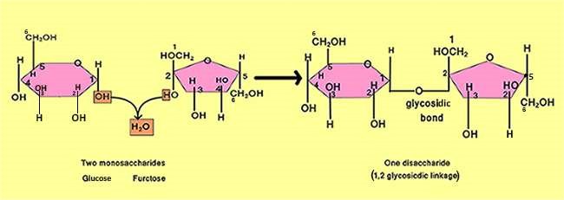

*Fig. 2.5 A disaccharide. Note carefully the glycosidic linkage between the two monosaccharides.*

*Animation 2.5: Carbohydrates*

*Source and Credit:*

*answer*

[*s*](http://www.answers.com/Q/What_elements_compose_carbohydrates)

**Polysaccharides:** Polysaccharides are the most complex and the most abundant carbohydrates in nature. They are usually branched and tasteless. They are formed by several monosaccharide units linked by glycosidic bonds (Fig. 216). Polysaccharides have high molecular weights and are only sparingly soluble in water. Some biologically important polysaccharides are starch, glycogen, cellulose, dextrins, agar, pectin, and chitin.

*Animation 2.6: Structural Features of Polysaccharides*

*Source and Credit:*

*biologie.uni-hambur*

[*g*](http://www1.biologie.uni-hamburg.de/b-online/library/newton/Chy251_253/Lectures/CarbohydratesIII/Carbo3FS.html)

**Starch:** It is found in fruits, grains, seeds, and tubers. It is the main source of carbohydrates for animals. On hydrolysis, it yields glucose molecules. Starches are of two types, amylose and amylopectin. Amylose starches have unbranched chains of glucose and are soluble in hot water. Amylopectin starches have branched chains and are insoluble in hot or cold water. Starches give blue colour with iodine.

*Animation 2.7: Starch*

*Source and Credit:* [*dynamicscience*](http://www.dynamicscience.com.au/tester/solutions1/chemistry/foodchemistry/starch.htm)

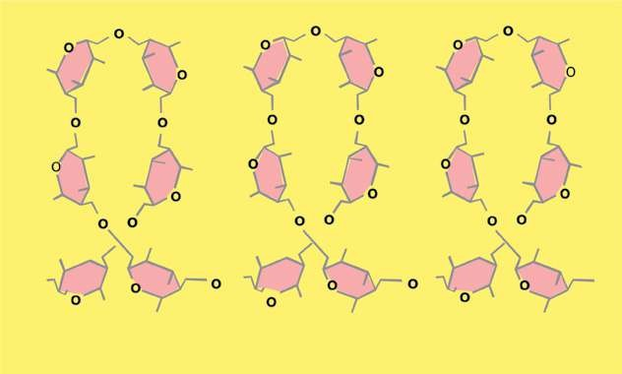

*Fig 2.6.: Polysaccharides are polymers of monosaccharides.*

**Glycogen:** It is also called animal starch. It is the chief form of carbohydrate stored in animal body. It is found abundantly in liver and muscles, though found in all animal cells. It is insoluble in water, and gives red colour with iodine. It also yields glucose on hydrolysis.

**Cellulose:** It is the most abundant carbohydrate in nature. Cotton is the pure form of cellulose. It is the main constituent of cell walls of plants and is highly insoluble in water. On hydrolysis it also yields glucose molecules. It is not digested in the human digestive tract. In the herbivores, it is digested because of micro-organisms (bacteria, yeasts, protozoa) in their digestive tract. These micro-organisms secrete an enzyme called cellulase for its digestion. Cellulose gives no colour with iodine.

### LIPIDS

The lipids are a heterogenous group of compounds related to fatty acids. They are insoluble in water but soluble in organic solvents such as ether, alcohol, chloroform and benzene. Lipids include fats, oils, waxes, cholesterol, and related compounds.

Lipids as hydrophobic compounds, are components of cellular membranes. Lipids are also used to store energy. Because of higher proportion of C-H bonds and very low proportion of oxygen, lipids store double the amount of energy as compared to the same amount of any carbohydrate. Some lipids provide insulation against atmospheric heat and cold and also act as water proof material. Waxes, in the exoskeleton of insects, and cutin, an additional protective layer on the cuticle of epidermis of some plant organs e.g. leaves, fruits, seeds etc., are some of the main examples.

Lipids have been classiied as acylglycerols, waxes, phospholipids, sphingolipids, glycolipids and terpenoid lipids including carotenoids and steroids. The structure of some of these lipids is given below.

#### Acylglycerols

Acylglycerols are composed of glycerol and fatty acids (Fig. 2.7). The most widely spread acyl glycerol is triacyl glycerol, also called triglycerides or neutral lipids. Chemically, acylglycerols can be deined as esters of fatty acids and alcohol. An ester is the compound produced as the result of a chemical reaction of an alcohol with an acid and a water molecule is released as shown below:

##### C2H5OH + HOOCCH3 8 C2H5OCOCH3 + H20 alcohol acetic acid an ester

As indicated by dotted squares, OH is released from alcohol and H from an acid.

H and OH combine and form a water molecule. Fatty acids are one of the most important components of triglycerides.

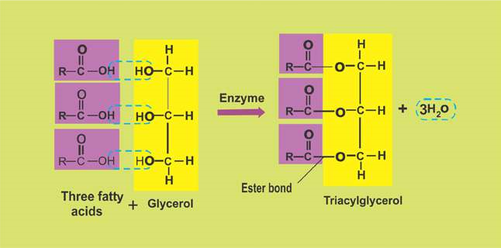

*Fig. 2.7: Triacylglycerol is composed of one glycerol and three fatty acid molecules.*

*Animation 2.8: Triglyceride*

*Source and Credit:* [*i-biology*](https://i-biology.net/ibdpbio/01-cells-and-energy/carbohydrates-lipids-and-proteins-inc-ahl-75-and-c1/)

Fatty acids contain even numbers ( 2-30) of carbon atoms in straight chain attached with hydrogen and having an acidic group COOH (carboxylic group). They may contain no double bond (saturated fatty acids) or up to 6 double bonds (unsaturated fatty acids). In animals the fatty acids are straight chains (Fig. 2.8.), while in plants these may be branched or ringed. Solubility of fatty acids in organic solvents and their melting points increase with increasing number of carbon atoms in chain. Palmitic acid (C16) is much more soluble in organic solvent than butyric acid (C4). The melting point of palmitic acid is 63.1°C as against -8°C for butyric acid.

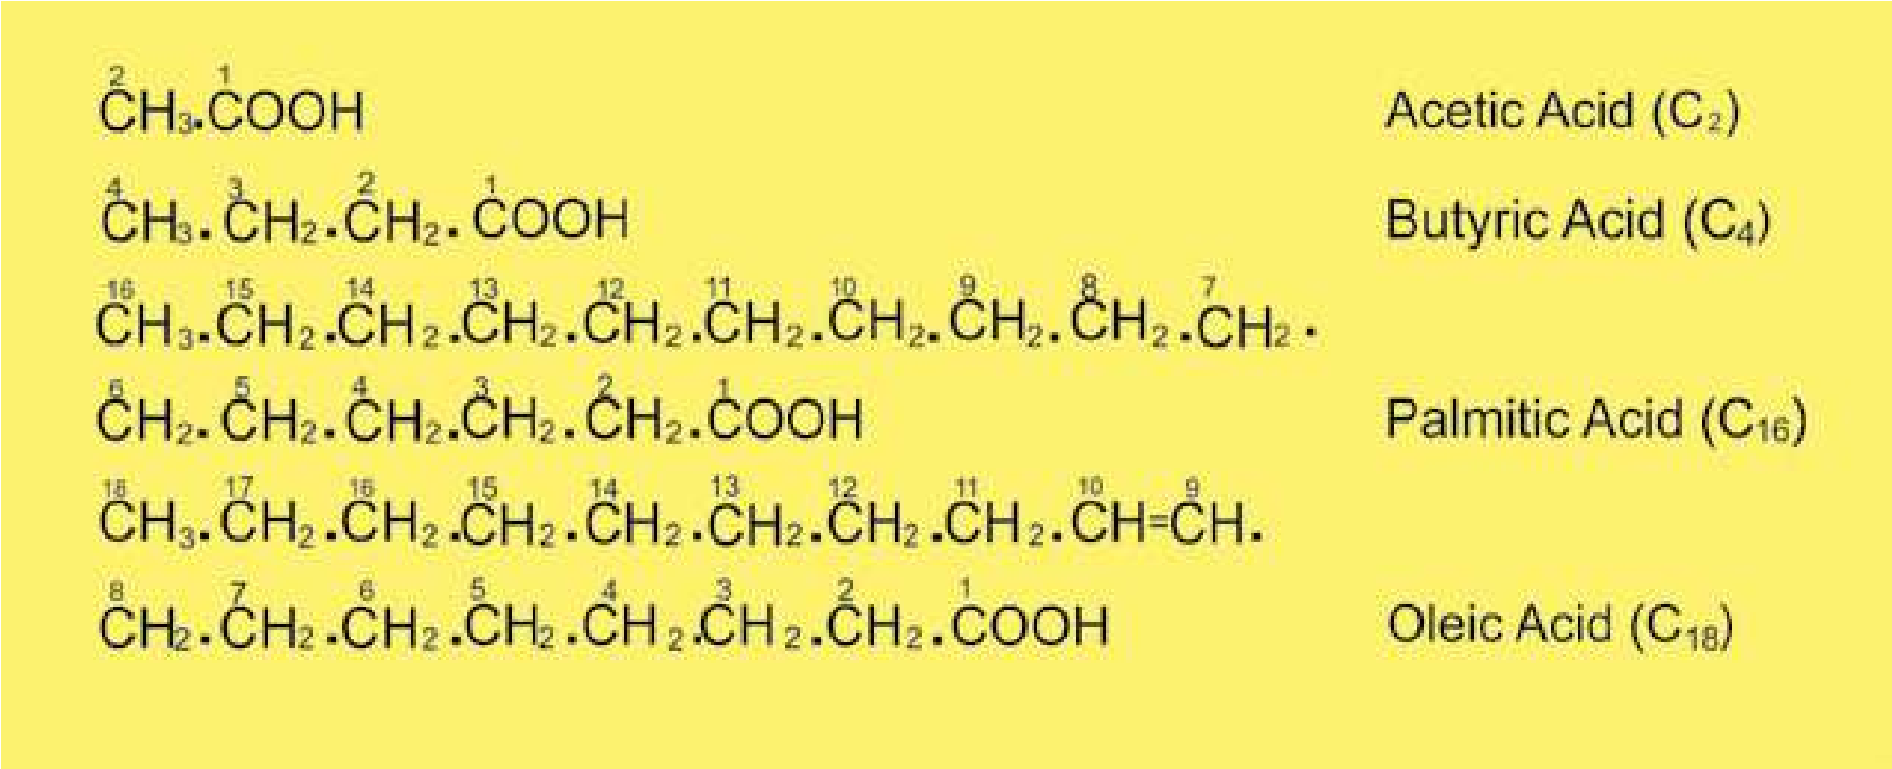

*Fig. 2.8: Some fatty acids with carbon numbers 2-18 are shown. Oleic acid is an unsaturated fatty acid (note a double bond between C9 and C10). Other fatty acids are saturated.*

Fats containing unsaturated fatty acids are usually liquid at room temperature and are said to be oils. Fats containing saturated fatty acids are solids. Animal fats are solid at room temperature, whereas most of the plant fats are liquids. Fats and oils are lighter than water and have a speciic gravity of about 0.8. They are not crystalline but some can be crystallized under speciic conditions.

#### Waxes

Waxes are widespread as protective coatings on fruits and leaves. Some insects also secrete wax. Chemically, waxes are mixtures of long chain alkanes (with odd number of carbons atoms ranging from C25 to C35) and alcohols, ketones and esters of long chain fatty acids. Waxes protect plants from water loss and abrasive damage. They also provide water barrier for insects, birds and animals such as sheep.

#### Phospholipids

Phospholipids are derivatives of phosphatidic acid (Fig.2.9.), which are composed of glycerol, fatty acids and phosphoric acid. Nitrogenous bases such as choline, ethanolamine and serine are important components of phospholipids. They are widespread in bacteria, animal and plant cells and are frequently associated with membranes. Phosphatidylcholine is one of the common phospholipids.

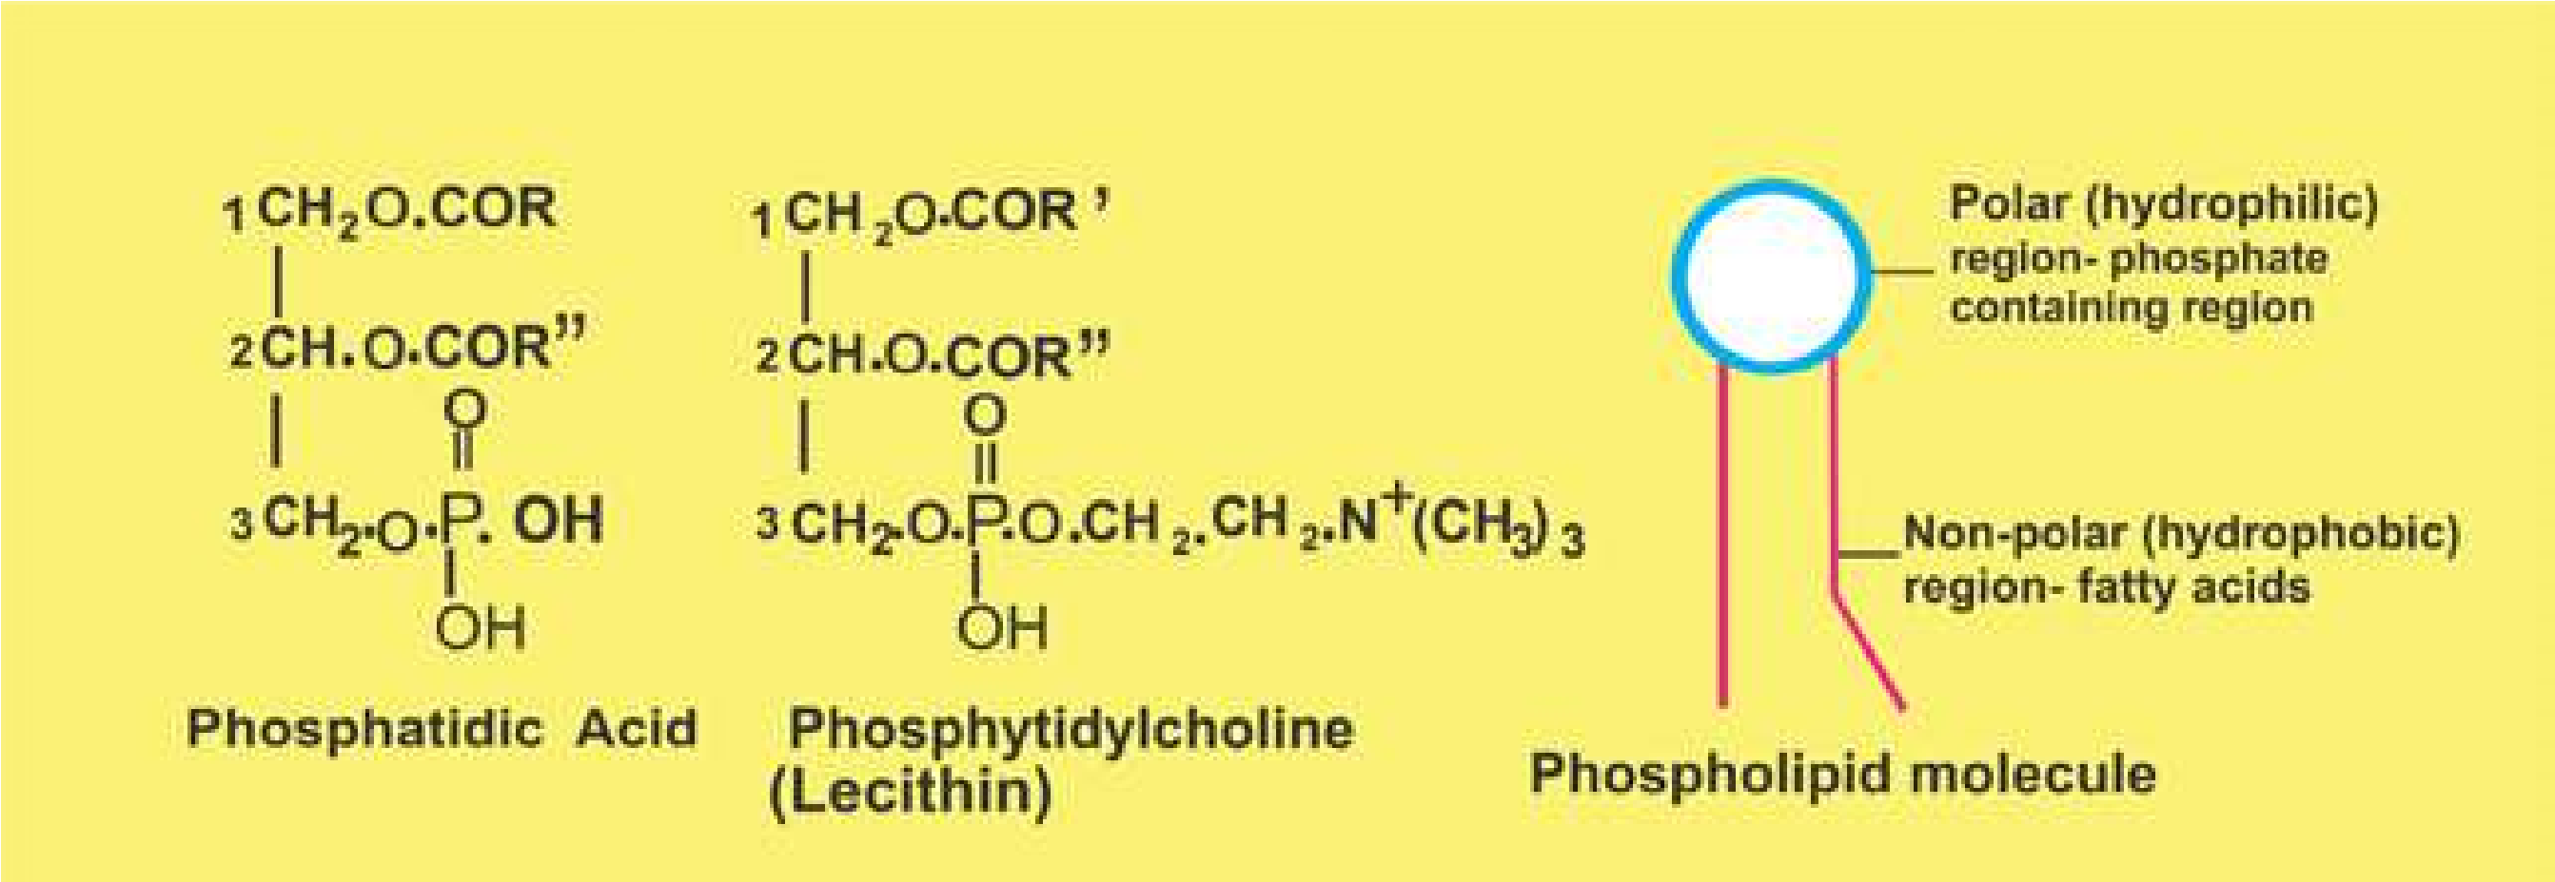

*Fig. 2.9.: Phosphatidic acid is composed of glycerol, 2 fatty acids (on Cl and C2), and a phosphoric acid on C3 of glycerol. In phospholipid a nitrogenous base (e.g. choline) is attached to phosphoric acid in phosphatidic acid.*

#### Terpenoids

Terpenoids are a very large and important group of compounds which are made up of simple repeating units, isoprenoid units. This unit by condensation in diferent ways gives rise to compounds such as rubber, carotenoids, steroids, terpenes etc. Lipids constitute major source of energy, and play an important role in the structure of membranes of the cell and of organelles found in the cell. They also provide insulation, mechanical protection and protection from water loss and abrasive damage.

### PROTEINS

Proteins are the most abundant organic compounds to be found in cells and comprise over 50% of their total dry weight. They are present in all types of cells and in all parts of the cell.

Proteins perform many functions. They build many structures of the cell. All enzymes are proteins and in this way they control the whole metabolism of the cell. As hormones, proteins regulate metabolic processes. Some proteins (e.g. hemoglobin) work as carriers and transport speciic substances such as oxygen, lipids, metal ions, etc. Some proteins called antibodies, defend the body against pathogens. Blood clotting proteins prevent the loss of blood from the body after an injury. Movement of organs and organisms, and movement of chromosomes during anaphase of cell division, are caused by proteins.

Proteins are polymers of amino acids, the compounds containing carbon, nitrogen, oxygen and hydrogen. The number of amino acids varies from a few to 3000 or even more in diferent proteins.

**Amino acids:** About 170 types of amino acids have been found to occur in cells and tissues. Of these, about 25 are constituents of proteins. Most of the proteins are however, made of 20 types of amino acids.

*Animation 2.9: Amino Acid*

*Source and Credit:*

*wikipedi*

[*a*](https://en.wikipedia.org/wiki/Amino_acid)

All the amino acids have an amino group (-NH2) and a carboxyl group (-COOH) attached to the same carbon atom, also known as alpha carbon. They have the general formula as:

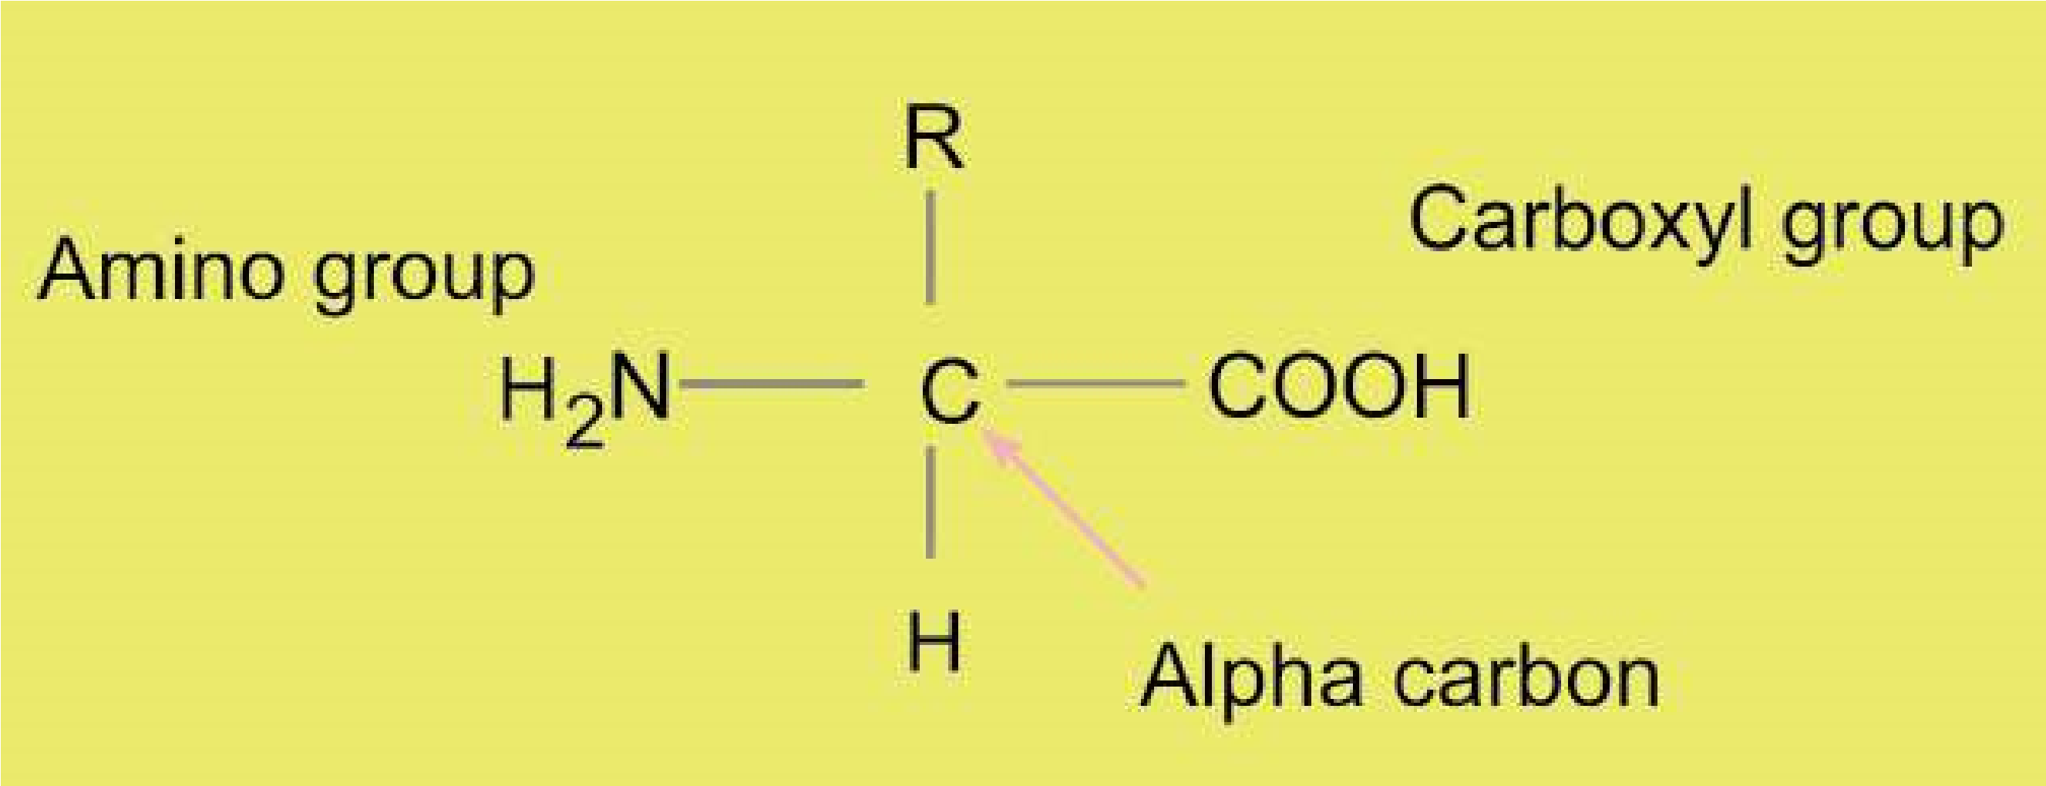

R may be a hydrogen atom as in glycine, or CH3 as in alanine, or any other group. So amino acids mainly difer due to the type or nature of R group.

Amino acids are linked together to form polypeptides **proteins**. The amino group of one amino acid may react with the carboxyl group of another releasing a molecule of water. For example, glycine and alanine may combine as shown in Fig.2.10.

The linkage between the hydroxyl group of carboxyl group of one amino acid and the hydrogen of amino group of another amino acid release H20 and C - N link, to form a bond called **peptide bond**. The resultant compound glycylalanine, has two amino acid subunits and is a dipeptide. A dipeptide has an amino group at one end and a carboxyl group at the other end of the molecule. So both reactive parts are again available for further peptide bonds to produce tripeptides, tetrapeptides, and pentapeptides etc, leading to polypeptide chains.

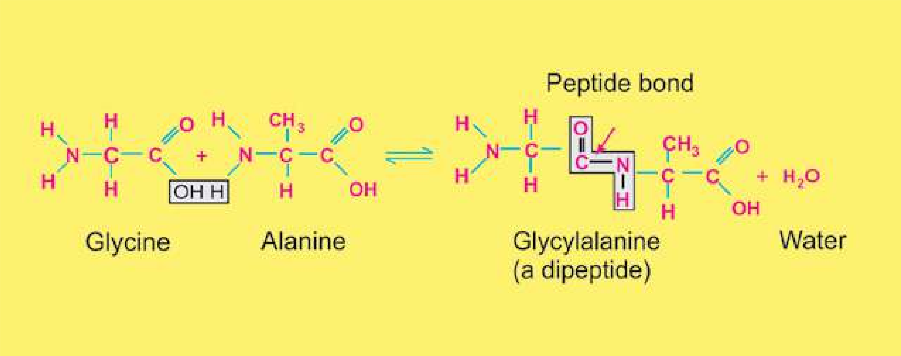

*Fig. 2.10 Peptide linkage - formation of peptide bond*

### STRUCTURE OF PROTEINS

Each protein has speciic properties which are determined by the number and the speciic sequence of amino acids in a molecule, and upon the shape which the molecule assumes as the chain folds into its inal, compact form. There are four levels of organization which are described below.

**Primary structure:** The primary structure comprises the number and sequence of amino acids in a protein molecule. F. Sanger was the irst scientist who determined the sequence of amino acids in a protein molecule. After ten years of careful work, he concluded, that insulin is composed of 51 amino acids in two chains.

One of the chains had 21 amino acids and the other had 30 amino acids and they were held together by disulphide bridges. Haemoglobin is composed of four chains, two alpha and two beta chains. Each alpha chain contains 141 amino acids, while each beta chain contains 146 amino acids (Fig. 2.11). The size of a protein molecule is determined by the type of amino acids and the number of amino acids comprising that particular protein molecule.

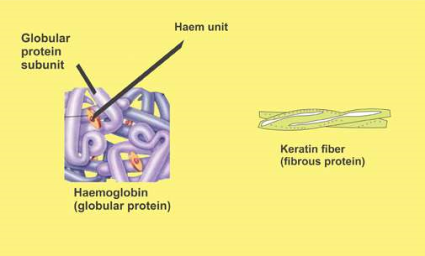

*Fig. 2.11. Polypeptide chains in keratin (ibrous protein ) and in haemoglobin (globular protein) are held together to form respective functional proteins.*

Now we know that there are over 10,000 proteins in the human body which are composed of unique and speciic arrangements of 20 types of amino acids. The sequence is determined by the order of nucleotides in the DNA. The arrangement of amino acids in a protein molecule is highly speciic for its proper functioning. If any amino acid is not in its normal place, the protein fails to carry on its normal function. The best example is the sickle cell hemoglobin of human beings. In this case only one amino acid in each beta chain out of the 574 amino acids do not occupy the normal place in the proteins (in fact this particular amino acid is replaced by some other amino acid), and the hemoglobin fails to carry any or suicient oxygen, hence leading to death of the patient.

**Secondary structure:** The polypeptide chains in a protein molecule usually do not lie lat. They usually coil into a helix, or into some other regular coniguration. One of the common secondary structures is the a-helix. It involves a spiral formation of the basic polypeptide chain. The a-helix is a very uniform geometric structure with 3.6 amino acids in each turn of the helix. The helical structure is kept by the formation of hydrogen bonds among amino acid molecules in successive turns of the spiral. b-pleated sheet is formed by folding back of the polypeptide.

**Tertiary structure:** Usually a polypeptide chain bends and folds upon itself forming a globular shape. This is the proteins’ tertiary conformation. It is maintained by three types of bonds, namely ionic, hydrogen, and disulide (-S-S-). For example, in aqueous environment the most stable tertiary conformation is that in which hydrophobic amino acids are buried inside while the hydrophilic amino acids are on the surface of the molecule.

**Quaternary structure:** In many highly complex proteins, polypeptide tertiary chains are aggregated and held together by hydrophobic interactions, hydrogen and ionic bonds. This speciic arrangement is the quaternary structure. Haemoglobin, the oxygen carrying protein of red blood cells, exhibits such a structure.

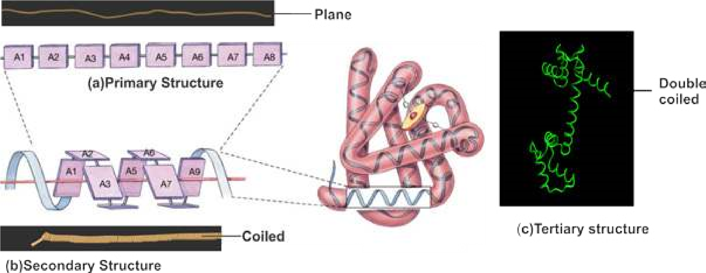

*Fig 2.12 Three levels of protein structures compared with a telephone wire*

#### Classiication of proteins

Because of the complexity of structure and diversity in their function, it is very diicult to classify proteins in a single well deined fashion. However, according to their structure, proteins are classiied as follows:

**Fibrous proteins:** They consist of molecules having one or more polypeptide chains in the form of ibrils. Secondary structure is most important in them. They are insoluble in aqueous media. They are non-crystalline and are elastic in nature. They perform structural roles in cells and organisms. Examples are silk iber (from silk worm, and spiders’ web) myosin (in muscle cells), ibrin (of blood clot), and keratin (of nails and hair).

**Globular proteins:** These are spherical or ellipsoidal due to multiple folding of polypeptide chains. Tertiary structure is most important in them. They are soluble in aqueous media such as salt solution, solution of acids or bases, or aqueous alcohol. They can be crystallized. They disorganize with changes in the physical and physiological environment. Examples are enzymes, antibodies, hormones and hemoglobin.

### NUCLEIC ACIDS (DNA AND RNA)

Nucleic acids were irst isolated in 1869 by F. Miescher from the nuclei of pus cells. Due to their isolation from nuclei and their acidic nature, they were named nucleic acids. Nucleic acids are of two types, deoxyribonucleic acid or DNA and ribonucleic acid or RNA. DNA occurs in chromosomes, in the nuclei of the cells and in much lesser amounts in mitochondria and chloroplasts. RNA is present in the nucleolus, in the ribosomes, in the cytosol and in smaller amounts in other parts of the cell.

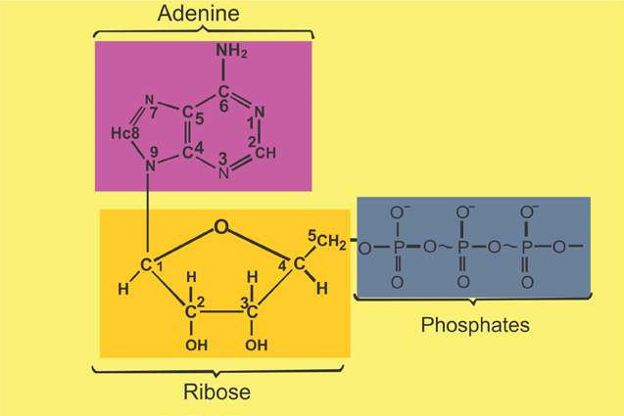

*Fig. 2.13. Structural formula of ATP (a nucleotide)*

Nucleic acids are complex substances. They are polymers of units called nucleotides. DNA is made up of deoxyribonucleotides, while RNA is composed of ribonucleotides. Each nucleotide is made of three subunits, a 5-carbon monosaccharide (a pentose sugar), a nitrogen containing base, and a phosphoric acid. Pentose sugar in ribonucleotide is ribose, while in deoxyribonucleotide it is deoxyribose. Nitrogenous bases are of two types, single-ringed pyrimidines, and double-ringed Purines. Pyrimidines are cytosine (abbreviated as C), thymine (abbreviated as T), and uracil (abbreviated as U). Purines are adenine (abbreviated as A) and guanine (abbreviated as G). Phosphoric acid (H3PO4 ) has the ability to develop ester linkage with OH group of Pentose sugar. In a typical nucleotide the nitrogenous base is attached to position 1 of pentose sugar, while phosphoric acid is attached to carbon at position 5 of pentose sugar (Fig 2.13 ).

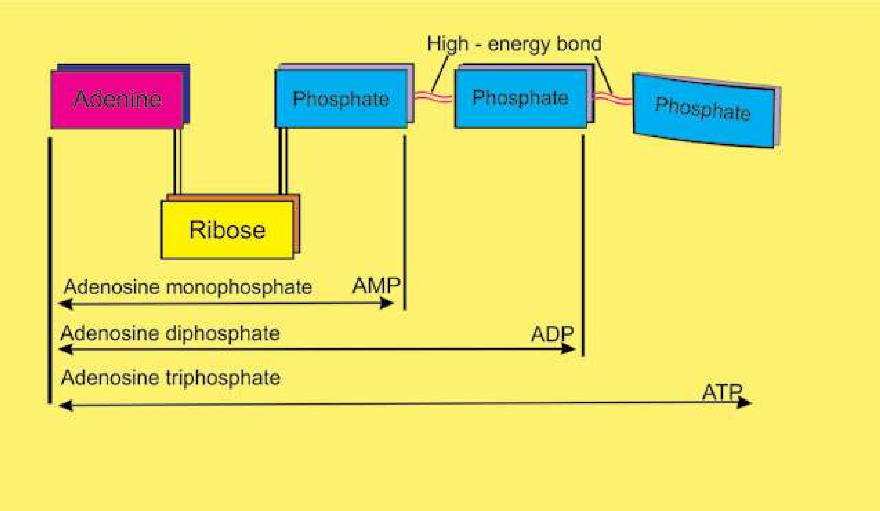

*Fig. 2.14 : Components of ATP, a nucleotide.*

The compound formed by combination of a base and a pentose sugar is called nucleoside. A nucleoside and a phosphoric acid combine to form a nucleotide. Each nucleotide of RNA contains ribose sugar, whereas sugar in each nucleotide of DNA is deoxyribose (one oxygen removed from OH group at carbon number 2). ATP is also an important nucleotide used as an energy currency by the cell (Fig.2.14.)

#### DNA (Deoxyribonucleic acid)

DNA is the heredity material. It controls the properties and potential activities of a cell. It is made of four kinds of nucleotides namely d-adenosine monophosphate (d-AMP), d-guanosine monophosphate (d-GMP), d-cytidine monophosphate (d-CMP), and d-thymidine monophosphate (d-TMP). These nucleotides are united with one another through phosphodiester linkages in a speciic sequence to form long chains known as polynucleotide chains (Fig.2.15). Two nucleotides join together to form dinucleotide whereas three join together to form trinucleotide. Nicotinamide adenine dinucleotide, abbreviated as NAD, is an example of dinucleotide. It is an important coenzyme in several oxidationreduction reactions in the cell.

*Animation 2.10: DNA*

*Source and Credit:*

*Myscienceboo*

[*k*](http://www.mysciencebox.org/node/622)

##### List of ribonucleotides and deoxyribonucleotides

|  |  |  |  |  |
| --- | --- | --- | --- | --- |
|  |  | **RNA DNA** | | |
| Nitrogenous base | Nucleosides (ribose + nitrogenous base) | Nucleotides (ribose + Nucleosides Nucleotides (deoxyribose nitrogenous (deoxyribose + + nitrogenous base +  base+phosphoric n i t r o g e n o u s phosphoric acid)  acid) base) | | |
| Adenine  Uracil  Guanine  Cytosine  Thymine | Adenosine  Uridine  Guanosine  Cytidine | AMP, ADP, ATP  UMP, UDP, UTP  GMP, GDP, GTP  CMP, CDP, CTP | d-Adenosine  d-Guanosine d-Cytidine d-Thymidine | dAMP, dADP, dATP  dGMP, dGDP. dGTP dCMP, dCDP, dCTP dTMP, dTDP. dTTP |

In 1951 Erwin Chargaf provided data about the ratios of diferent bases present in this molecule. This data suggested that adenine and thymine are equal in ratio and so are guanine and cytosine as shown below in Table 2.2.

**Table 2.2: Relative amounts of bases in DNA from various organisms (on percentage basis).**

|  |  |  |  |  |
| --- | --- | --- | --- | --- |
| **Source of DNA** | **Adenine** | **Guanine** | **Thymine** | **Cytosine** |
| Man | 30.9 | 19.9 | 29.4 | 19.8 |
| Sheep | 29.3 | 21.4 | 28.3 | 21.0 |
| Wheat | 27.3 | 22.7 | 27.1 | 22.8 |
| Yeast | 31.3 | 18.7 | 32.9 | 17.1 |

Maurice Wilkins and Rosalind Franklin used the technique of X-ray difraction to determine the structure of DNA. At the same time James D. Watson and Francis Crick built the scale model of DNA. All the data thus obtained strongly suggested that DNA is made of two polynucleotide chains or strands. The two strands are coiled round each other in the form of a double helix. Coiling of two strands is opposite i.e. they are coiled antiparallel to each other. The two chains are held together by weak bonds (hydrogen bonds). Adenine (A) is always opposite to thymine (T), and guanine (G) and cytosine (C) are opposite to each other. There are two hydrogen bonds between A and T pair, and three hydrogen bonds between G and C pair. The two strands are wound around each other so that there are 10 base pairs in each turn of about 34 Angstrom units (one Angstrom = one 100-millionth of a centimeter) (Fig.2.15).

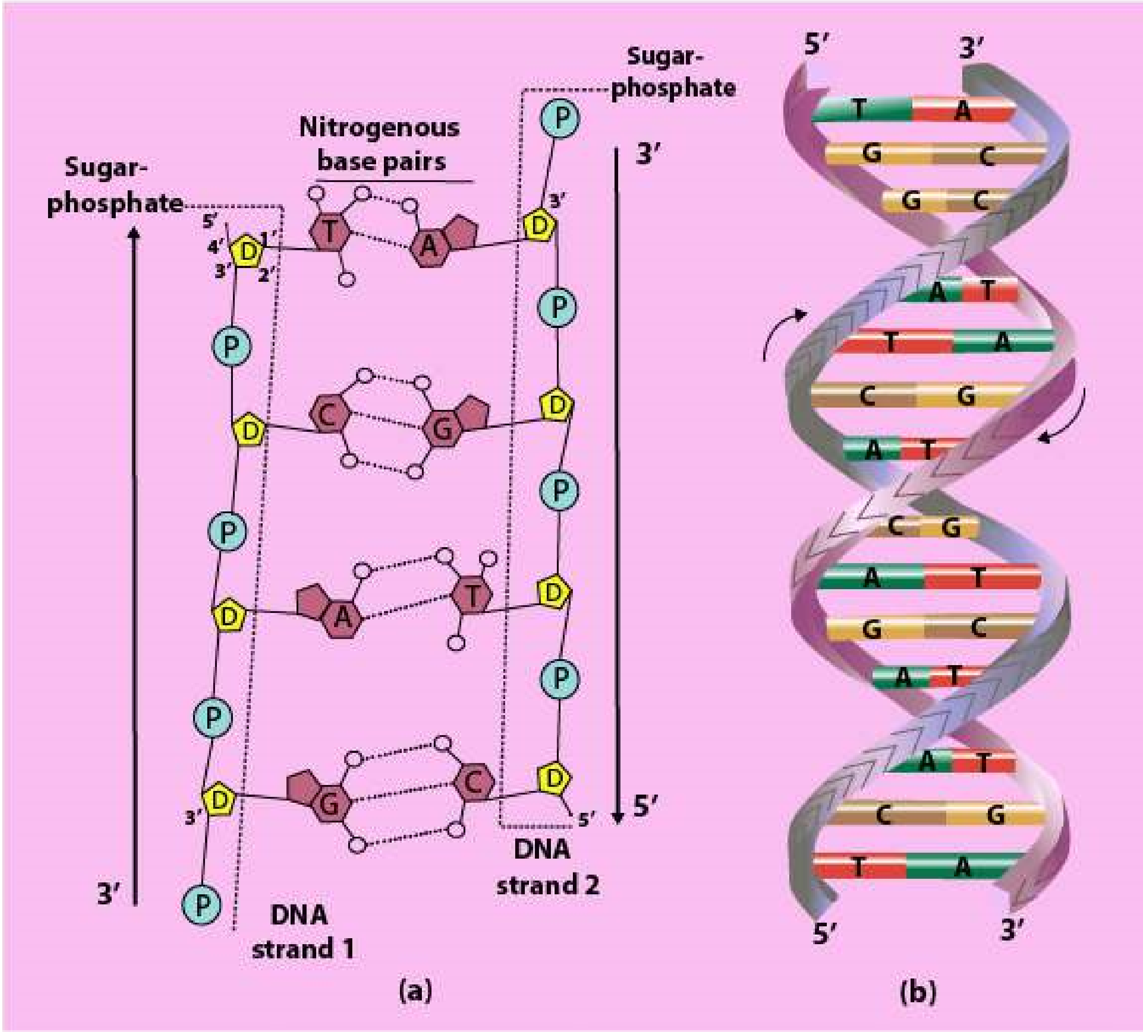

*Fig. 2.15 Model of DNA. Double helical structure of DNA proposed by Watson & Crick (b). A hypothetical sequence of nucleotides (on the left side) shows hydrogen bonding between the complementary bases. Note a double boud between A and T, and triple bond between C and G (a).*

The amount of DNA is ixed for a particular species, as it depends upon the number of chromosomes.

The amount of DNA in germ cells (sperms and ova) is one half to that of somatic cells (Table 2.3).

**Table 2.3 Amount of DNA/nucleus in diferent types of cells of a chicken (bird) and a carp (ish).**

|  |
| --- |
| **Type of cell Amount of DNA/nucleus(in picogram)**  **Chicken Crap** |
| Red Blood Cells 2.3 3.3 Liver cells 2.4 3.3  Kidney cells 2.4 3.3  Sperm cells 1.3 1.6 |

All the information for the structure and functioning of a cell is stored in DNA. For example in the chromosome of the bacterium E.coli, each of the paired strand of DNA contains about 5 million bases arranged in a particular linear order, the information in those bases is divided into units of several hundred bases each. Each unit is a gene, a unit of biological inheritance. The E.coli genome consists of 4,639,221 base pairs, which code for at least 4288 proteins.

*Haemophilus inluenzae* is the irst microbe to have the genome completely sequenced and this was published on July 28, 1995. **RNA (Ribonucleic Acid)**

Like DNA, RNA is a polymer of ribonucleotides. The RNA molecules occur as single strand, which may be folded back on itself, to give double helical characteristics. The nitrogenous bases form the usual complementary pairing viz. cytosine (C) with guanine (G) and uracil (U) with adenine (A). RNA is synthesized by DNA in a process known as **transcription.**

##### Types of RNA

Three main types of RNAs — messenger RNA (abbreviated as mRNA), transfer RNA (abbreviated as tRNA), and ribosomal RNA (abbreviated as rRNA) are recognized. All these three types of RNAs are synthesized from DNA in the nucleus and then are moved out in the cytoplasm to perform their speciic functions.

**Messenger RNA (mRNA):** As the name indicates it takes the genetic message from the nucleus to the ribosomes in the cytoplasm to form particular proteins. Messenger RNA carries the genetic information from DNA to ribosomes, where amino acids are arranged according to the information in mRNA to form speciic protein molecule. This type of RNA consists of a single strand of variable length. Its length depends upon the size of the gene as well as the protein for which it is taking the message. For example, for a protein molecule of 1,000 amino acids, mRNA will have the length of 3,000 nucleotides. mRNA is about 3 to 4% of the total RNA in the cell.

**Transfer RNA (tRNA):** It comprises about 10 to 20% of the cellular RNA. Transfer RNA molecules are small, each with a chain length of 75 to 90 nucleotides. It transfers amino acid molecules to the site where peptide chains are being synthesized. There is one speciic tRNA for each amino acid. So the cell will have at least 20 kinds of tRNA molecules. Transfer RNA picks up amino acids and transfers them to ribosomes, where they are linked to each other to form proteins.

**Ribosomal RNA (rRNA):** It is the major portion of RNA in the cell, and may be up to 80% of the total RNA. It is strongly associated with the ribosomal protein where 40 to 50% of it is present. It acts as a machinery for the synthesis of proteins. On the surface of the ribosome the mRNA and tRNA molecules interact to translate the information from genes into a speciic protein.

*Animation 2.11: RNA*

*Source and Credit:*

*Shapiro Grou*

[*p*](http://www-lmmb.ncifcrf.gov/users/bshapiro/rna3Dsda_index.html)

|  |
| --- |
| *Animation 2.12: RNA Source and Credit:* [*Shapiro Group*](http://www-lmmb.ncifcrf.gov/users/bshapiro/rna3Dsda_index.html) |

### CONJUGATED MOLECULES

Two diferent molecules, belonging to diferent categories, usually combine together to form conjugated molecules. Carbohydrates may combine with proteins to form glycoprotein or with lipids to form glycolipids. Most of the cellullar secretions are glycoprotein in nature. Both glycoproteins and glycolipids are integral structural components of plasma membranes. Lipoprotein formed by combination of lipids and proteins are basic structural framework of all types of membranes in the cells.

Nucleic acids have special ainity for basic proteins. They are combined together to form nucleoproteins. The nucleohistones are present in chromosomes. These conjugated proteins are not only of structural, but also are of functional signiicance. They play an important role in regulation of gene expression.

*Animation 2.13:* Conjugated Molecules *source and Credit:* [*fractalield*](http://www.fractalfield.com/conjugategravity/)

#### Exercise

1. **. Fill in the blanks.**
   1. The sum of all the chemical reactions taking place within a cell is called _______________________. ii. ______________________ is the basic element of organic compounds. iii. All the amino acids have an amino group and a carboxyl group attached to the same _______________________ atom. iv. ________________________ is the most abundant carbohydrate in nature.

V. Adenine and guanine are double ringed bases and are called _______________________.

1. **. Write whether the statement is ‘true’ or ‘false’ and write the correct statement if it is false.**
   1. A small proportion of water molecules are in ionized form ii. The covalent bond among two monosaccharides is called a peptide bond. iii. Glycogen is also called plant starch.

iv. Adenine is always opposite to guanine, cytosine and thymine are opposite to each other in DNA molecule.

V. DNA molecule is made of two polynucleotide strands

1. **Short questions.**
   1. Name the carbohydrates suitable as food for man. ii. Why are fats considered as high energy compounds? iii. What is the function of mRNA? iv. What is the general formula for amino acids?

v. What is the percentage of water in brain cells of man?

1. **Extensive questions.**
   1. Describe the importance of water for life.
   2. Describe what do you know about polysaccharides. iii. Write a short note on amino acids.